Raw EPIC Data Calibration

Alexander Cede^{1,2,4}, Liang Kang Huang^{2,3}, Gavin McCauley¹, Jay Herman^{2,5}, Karin Blank², Matthew Kowalewski², Alexander Marshak²
¹ SciGlob Instruments & Services LLC, Elkridge, MD, USA
² Goddard Space Flight Center, NASA, Greenbelt, MD, USA
³ Science Systems and Applications, Inc., Lanham, MD, USA
⁴ LuftBlick, Innsbruck, Austria
⁵ Joint Center for Earth Systems Technology, Baltimore, MD, USA

Abstract
EPIC (Earth Polychromatic Imaging Camera) raw level-0 (L0) data in one channel is a 12-bit 2048x2048 pixels image array plus auxiliary data such as telemetry, temperature readings, etc. The EPIC L1a processor applies a series of correction steps on the L0 data to convert them into corrected count rates (level-1a or L1a data): Dark correction, Enhanced pixel detection, Read wave correction, Latency correction, Non-linearity correction, Temperature correction, Conversion to count rates, Flat fielding, and Stray light correction. L1a images should have all instrumental effects removed and only need to be multiplied by one single number to obtain radiances, which are the basis for all higher-level EPIC products, such as ozone columns, vegetation index, etc. This paper gives an overview of the mathematics,the pre-launch, and on-orbit calibration behind each correction step.

1 Introduction
EPIC operates aboard the Deep Space Climate Observatory (DSCOVR) satellite, which is orbiting the Sun at the Lagrange 1-point L₁, about 1.5 million kilometers away from Earth [Marshak et al., 2018]. It measures the solar radiance backscattered from the sunlit-portion of the Earth using 10 narrow-band wavelength filters, from the ultraviolet (UV) to the near-infrared (NIR). The science products (L2 data, see also table 2.1) derived from these observations include total column ozone [Herman et al., 2020] and sulfur dioxide (SO₂) [Carn et al., 2018], aerosol information [Christian et al., 2019, Sasi et al., 2020, Xu et al., 2019], cloud [Molina et al., 2018] and vegetation [Marshak and Knyazikhin, 2017] properties, reflectivity [Wen et al., 2019] and atmospheric correction [Herman et al., 2020]. The sequence from raw data to final products is a 3-step process:

- L0 to L1a: L0 data in each channel are converted into corrected count rates (level-1a or L1a data). L1a images should have all instrumental effects removed, so that the resulting images are proportional to the true radiances.
- L1a to L1b: the exact latitude and longitude grid for the projection of the images onto the Earth’s surface is determined (geolocation). Then the L1a images from the different channels, which have a different geolocation as they are taken at different times (more than 6 min between the first and the last filter), are interpolated to a common grid, which gives level-1b (L1b) data.
- L1b to L2: the L1b images from one or more channels are converted into level-2 (L2) data through application of the algorithm specific for each output product.

This paper gives an overview of the mathematics, the pre-launch, and on-orbit calibration behind the first of the steps above that is the basis for all further processes. Section 2 gives a short overview of the instrument design and performance. The different calibration periods are listed in section 3. Section 4 goes through each of the steps to convert the L0 data in L1a data. Sections 5 and 6 discuss the EPIC pixel size on ground and L1a data uncertainty respectively. Conclusions are given in section 6.

2 Instrument overview
The EPIC instrument is described in detail in the DSCOVR Overview report [Atmospheric Data Science Center, 2016]. Here we give a brief overview of the optical elements that are relevant for this paper. The optical path of EPIC is shown in figure 2.1.

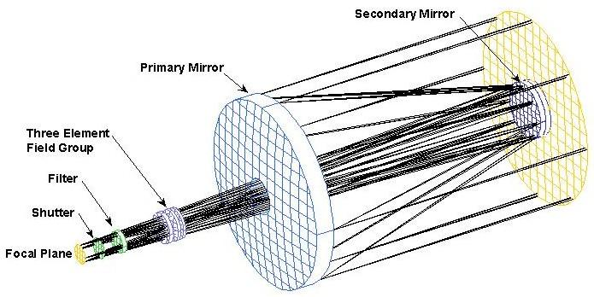
Figure 2.1: EPIC light path

As light enters the front end of the 286 cm focal length Cassegrain telescope, it is reflected by the 30.5cm diameter primary mirror onto the 9.5cm diameter secondary mirror. Light reflected by the secondary mirror passes through the center of the primary mirror, where it enters the camera assembly. A three-element fused silica field lens group is designed to correct for the inherent optical aberrations of the Cassegrain telescope such as coma, astigmatism, and field curvature. EPIC houses two filter wheels, each with 6 openings of 4cm diameter, of which 5 are equipped with an optical filter and one position is left open (figure 2.2). Each filter is a combination of a narrow band interference filter with a broadband blocking filter. The next element in the EPIC camera assembly is a 3-slit rotating wheel shutter to control the length of the exposure, i.e. the duration in which the detector actively collects photons of light. The filter specifications and the exposure times for each channel used in orbit are given in table 2.1. The filter bandwidths were decreased during refurbishment to increase exposure time to more than 20 ms so as to never use the smallest slit, which removes non-uniformity in exposure across the CCD caused by acceleration of the rotating shutter wheel.

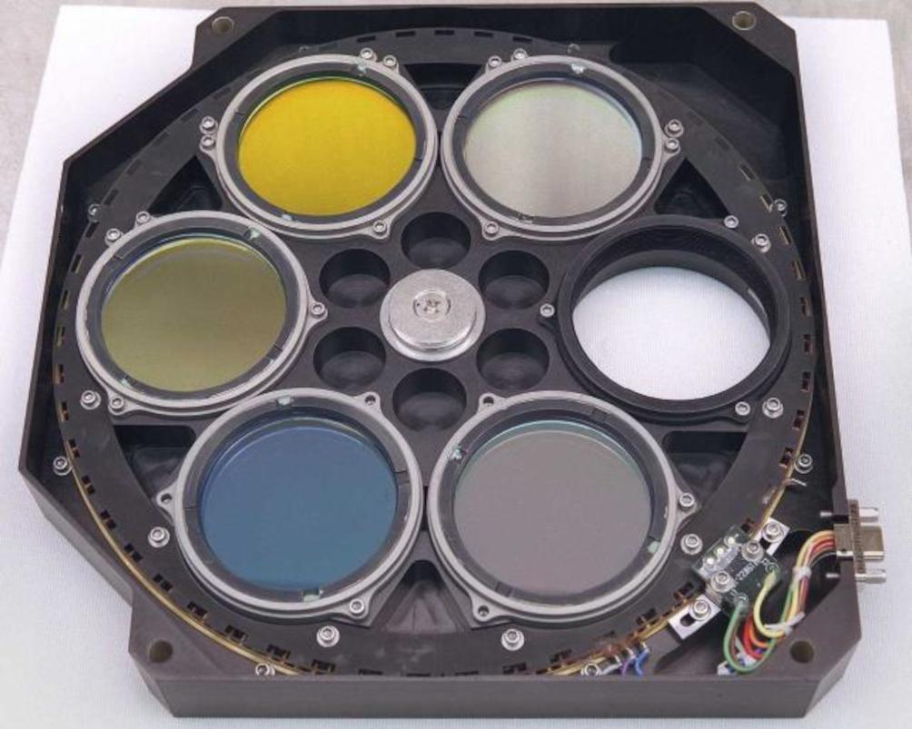
Figure 2.2: EPIC filter wheel 2.

Table 2.1: Specifications of the EPIC filters. Filter wheel 1 with filters 1 to 5 is closer to the primary mirror, filter wheel 2 with filters 6 to 10 is closer to the detector. The center wavelengths are given in nm-vacuum and the resolutions are given as the full width half maximum (FWHM) of the filter function. The exposure time is the one used in regular operation and is never changed. For the meaning of the stray light fraction see section 4.9. The primary science purpose indicates for which science L2 product the respective channel is used.
Filter  (Filter wheel) | Center  Wavelength  [nm] | Resolution  FWHM  [nm] | Exposure  Time  [ms] | Stray light  fraction  [%] | Primary science purpose
1 (1) | 317.5 | 1.1 | 654 | 13 | O₃, SO₂
2 (1) | 325.0 | 1.0 | 442 | 12 | O₃, SO₂
3 (1) | 340.0 | 2.7 | 67 | 12 | O₃, SO₂, Aerosols, Reflectivity
4 (1) | 388.0 | 2.6 | 87 | 14 | Aerosols, Reflectivity
5 (1) | 443.0 | 2.7 | 28 | 14 | Aerosols, Reflectivity, Vegetation
6 (2) | 551.0 | 3.0 | 70 | 13 | Aerosols, Reflectivity, Vegetation
7 (2) | 687.75 | 0.9 | 75 | 18 | Clouds O₂ B-Band
8 (2) | 680.0 | 1.7 | 32 | 20 | Aerosols, Reflectivity, Vegetation, Clouds
9 (2) | 764.0 | 1.0 | 101 | 19 | Clouds O₂ A-Band
10 (2) | 779.5 | 1.8 | 49 | 18 | Aerosols, Reflectivity, Vegetation, Clouds

In the focal plane of the beam is the EPIC detector, a thinned, backside-illuminated hafnium coated silicon wafer CCD with an anti-reflection coating. The CCD was expected to operate at -40°C in flight mode, but the realized operating temperature is -20°C. It contains 2048 x 2048 square pixels of 15 microns length each, resulting in a total imaging area of slightly more than 3 x 3 cm². In angular measurements, the pointing distance between two pixels is 1.078 arcsecs. Therefore, the final total field of view (FOV) of the EPIC telescope is 0.607°, limited by the horizontal and vertical edges of the CCD (see figure 2.3, where the gray areas in the corners of each panel show the region outside the FOV).

The EPIC CCD can be drained (readout) from two opposite corners. In regular operation the same corner is always used. If the readout through that corner fails, EPIC can switch to the readout from the other corner. While the entire EPIC calibration has been done for both readout modes, all results shown in this paper refer to the regular readout mode.

EPIC is read in a so-called “over-scanned” mode. This means although there are 2048 x 2048 pixels, 2056 readings in both row and column direction are done. Therefore, the pixels from the first 8 rows and columns do not include those photons that have been accumulated during the exposure time, but instead only the photons caused by thermal electrons during the readout process. The pixels in these rows and columns are called “oversampled pixels” and are used in the dark correction (section 4.1).

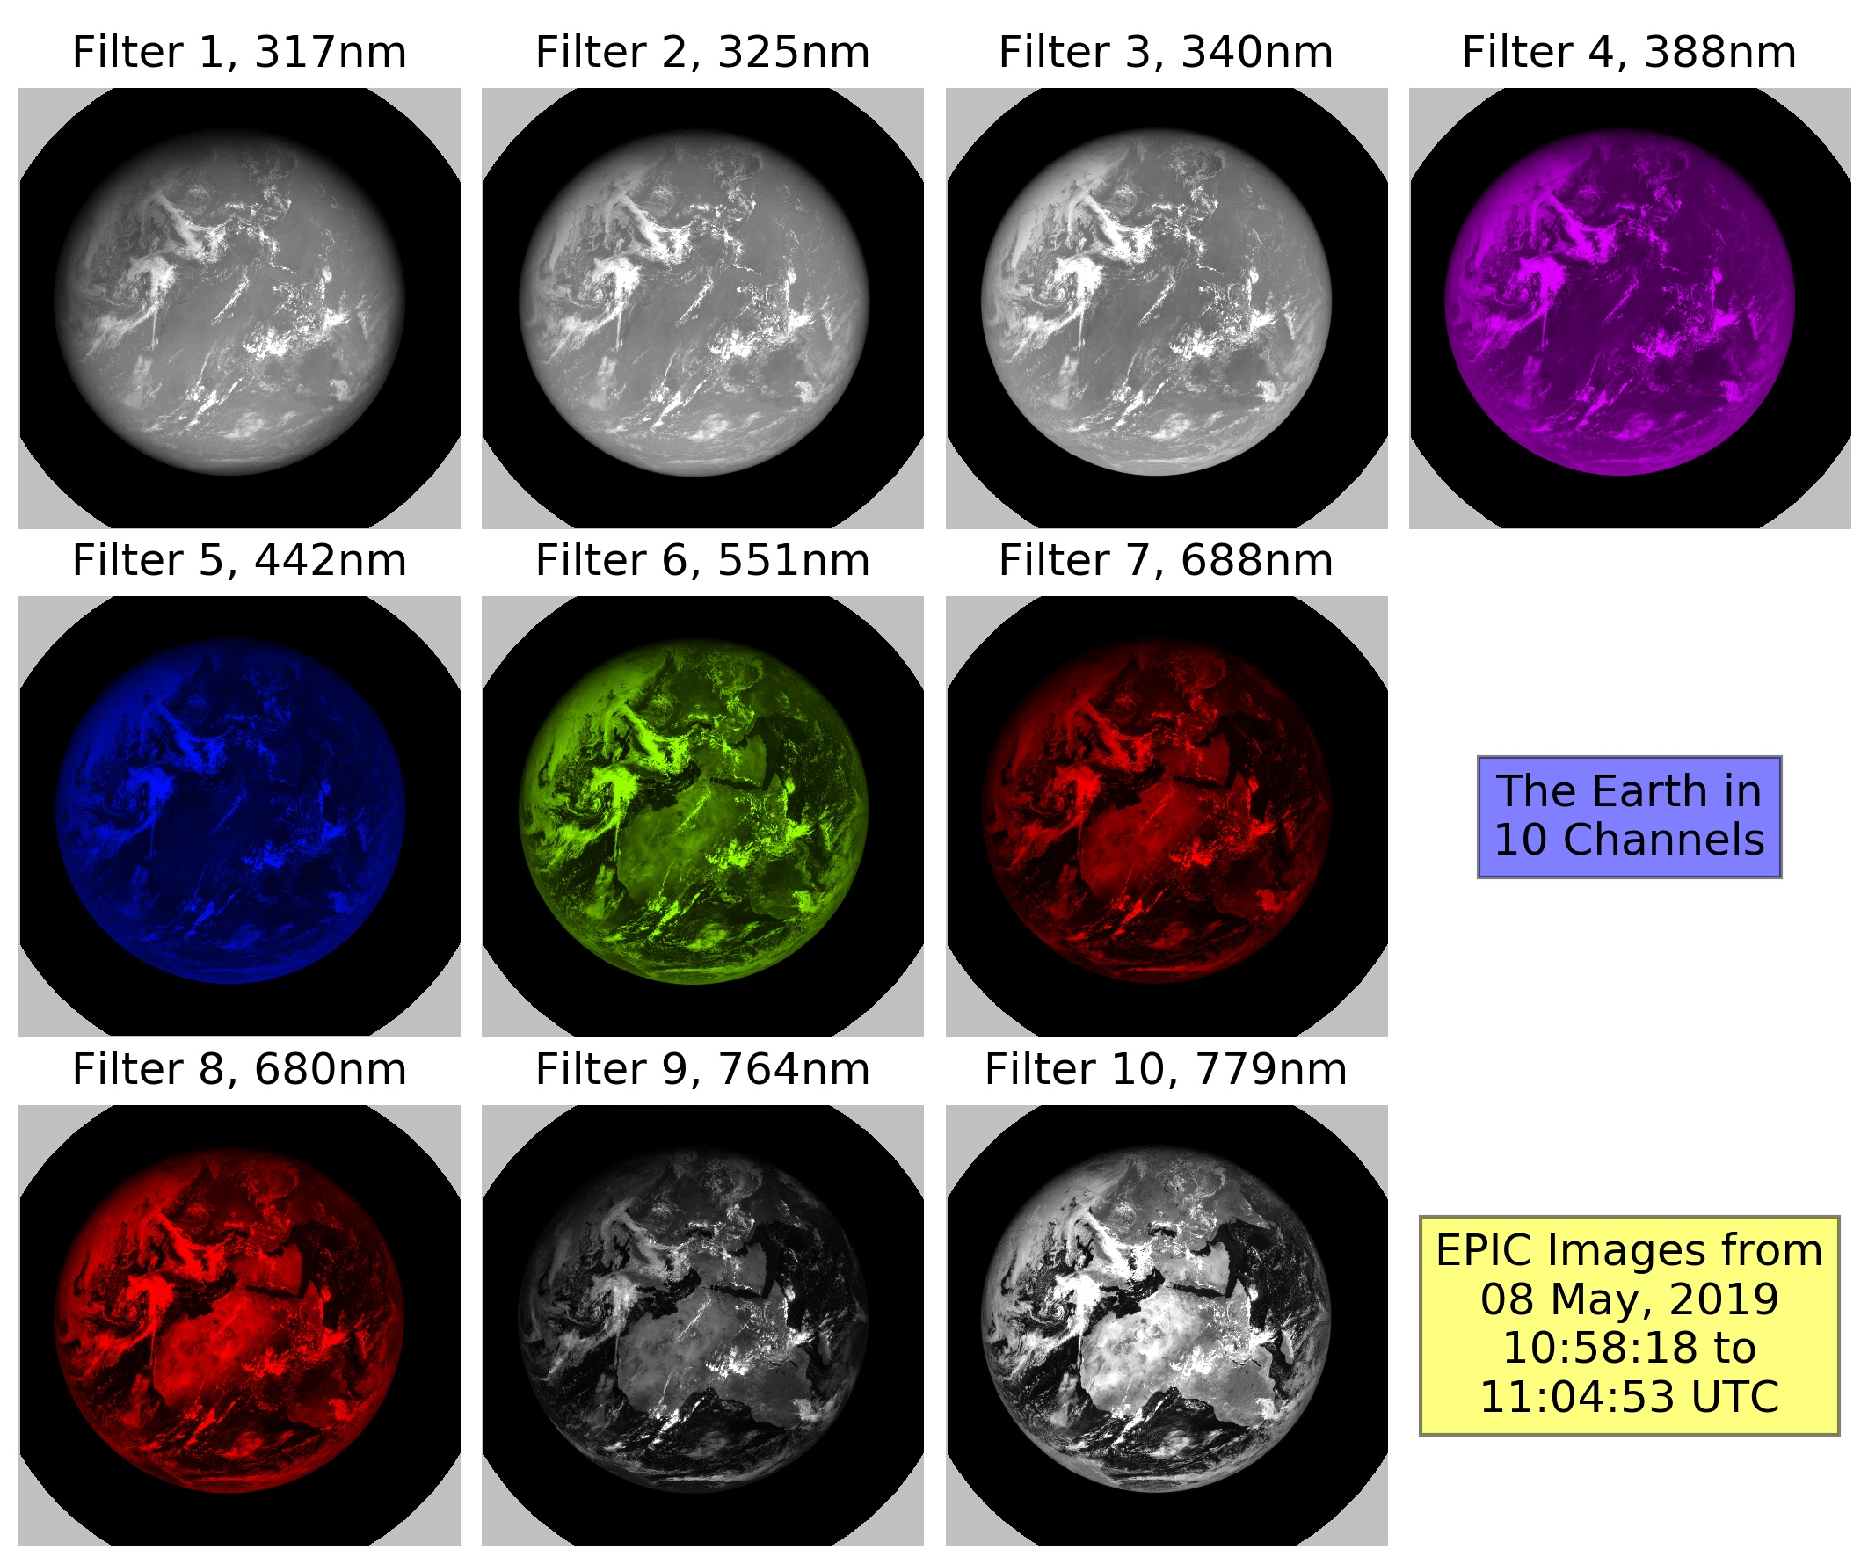
Figure 2.3: EPIC L1a images for each channel taken on 8 May 2019 around 11 UTC. One such full set of 10 images is taken by EPIC approximately every 65 min during the Northern Hemisphere summer and every or 85 min during the Northern Hemisphere winter. The gray areas in the corners of each panel show the regions outside of the FOV of the telescope. Areas with no signal are plotted in black color. Higher signal intensity is plotted in shades of white for the UV filters 1 to 3 and the NIR filters 9 and 10 and for the visible filters in that color our eye would see if we placed the respective filter in front of it. The contrast between dark and bright areas in the images is smallest for the UV channels due to the strong Rayleigh scattering, and increases with wavelength. The filter pairs 7-8 and 9-10 are relatively close in wavelength, but one channel in each pair is strongly absorbed by molecular oxygen (filters 7 and 9), which causes a much darker image of the Earth compared to the other filter in the pair.

3 Calibration periods
Most of the information used for the EPIC raw data calibration was obtained during in-flight calibration periods that are listed in this section. A laboratory version of full calibration for EPIC L1a processing was finished before the launch of DSCOVR. The necessary measurements were obtained during two dedicated pre-launch calibration campaigns (sections 3.1 and 3.2). This first calibration version was then modified based on information obtained during two on-orbit calibration campaigns (sections 3.3 and 3.4). Finally, the operational EPIC images are used to determine if the instrumental characteristics are changing with time. The observed small changes have been used to modify the calibration constants in the UV channels.

3.1 Calibration period “CalLM”
The first calibration period “CalLM” took place at the Lockheed Martin Advanced Technology Center, Palo Alto, CA. Preparatory measurements were taken in air with the detector at room temperature during July and August 2011. Final measurements were obtained at flight conditions in the vacuum chamber with cooled detector from 15 to 20 Sept 2011. More than 3000 images were taken in total. The calibration setup is shown in figure 3.1 [Cede et al., 2011]. It allowed EPIC to be illuminated with beams of different divergence, from point sources used for stray light calibration to extended sources that overfilled the instrument’s total FOV.

3.2 Calibration period “CalGSFC”
The second pre-launch calibration period “CalGSFC” took place in February 2014 at NASA / Goddard Space Flight Center, Greenbelt, MD. In this period measurements were taken in the vacuum chamber at flight conditions for 7 days with over 600 images in total. The focus was to repeat the original calibration sequences that did not give conclusive results in the 2011 tests during CalLM, namely the non-linearity and flat field calibration. In this calibration EPIC was illuminated by a beam reflected from a diffuser plate that overfilled the instrument’s FOV.

3.3 Calibration period “CalDark”
The period from DSCOVR’s launch on 11 February 2015 to reaching its orbital location at the Earth-Sun Lagrange-1 point on 7 June 2015 was used for extensive dark count measurements with the closed telescope and is called “CalDark”. More than 1000 dark images taken to complement the pre-launch dark count calibration.

3.4 Calibration period “CalMoon”
At the beginning of the mission, EPIC was pointed towards the Moon instead of the Earth on several occasions in between regular operation (“lunar observations”). They were usually taken at times where the angular distance between Earth and Moon as seen from EPIC was at a maximum, which corresponds approximately to half-moon phases on Earth. The longest of these periods is called “CalMoon” and lasted from 15 to 19 Aug 2015, where the lunar surface was “moved” over 36 positions across the detector. Images for 5 filters were taken at each position. Additional shorter periods with lunar observations have been and continue to be inserted in the regular EPIC observations schedule (26 of such periods as of March 2021) corresponding to the full moon as seen from Earth. The objectives of the lunar observations are to test the stray light and flat field calibrations, and also to check the radiometric stability of EPIC over time.

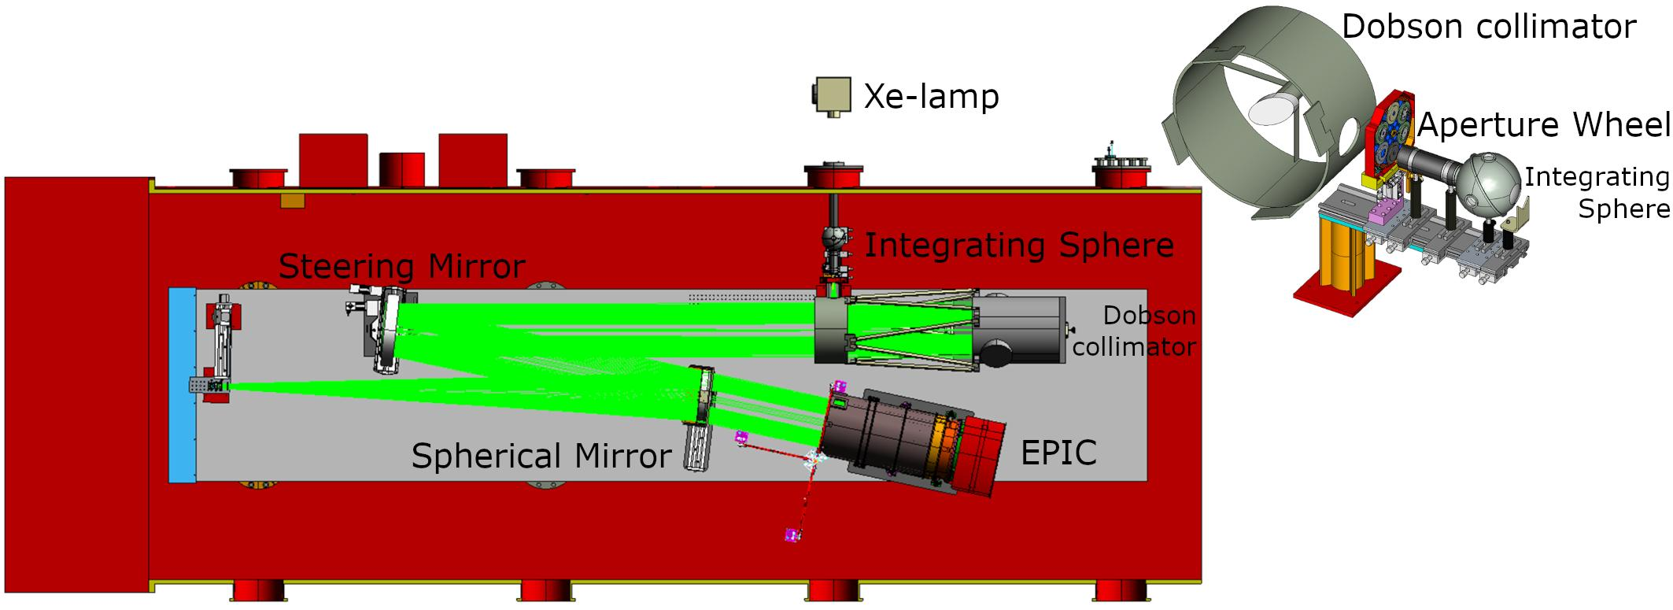
Figure 3.1: Setup during EPIC pre-launch calibration at the Lockheed Martin Advanced Technology Center at flight conditions. The light from a 1500W xenon-lamp enters the vacuum chamber through a window into an integrating sphere. After exiting the sphere, the light passes a focusing lens and a selected ‘target’ on the 6-position aperture wheel (most targets are holes of different diameters). Then it enters a Dobsonian collimator, which produces an extended beam with a divergence determined by the target. The beam is then reflected by the steering mirror and enters EPIC. Optionally a spherical mirror can be placed in the optical path for reference measurements.

4 L1a processing steps
Any measurement device has imperfections, so does EPIC. For example, the radiometric sensitivity and the dark counts vary across the detector, stray light affects the pixels in different ways, the read-out mechanism has a latency, etc. In processing the raw L0 data to L1a data we try to correct for all such imperfections in the best possible way. This process is done in several steps, which are listed in table 4.0.1. If everything was done “perfectly”, then each of the more than 4 million EPIC pixels would give exactly the same L1a output, in case it was receiving the same input, and consequently the entire image would only need to be multiplied by one single number to convert from corrected count rates to radiances. Apart from the L1a data array, the L1a output also includes a so-called “pixel type array” of the same dimension as the image itself. The pixel types give information about whether the specific pixel is outside the EPIC FOV, is oversampled, is on or off “target” (i.e. inside or outside the disk of the Earth or the Moon), or is saturated or enhanced (see section 4.2).

Some of the L1a corrections have less impact on the data than others. For those, the data would only differ from the “correct” data by a small amount if the corrections were not applied (see table 4.0.1). In this section we describe each correction step separately, with a focus on those with more significant effects on the data, i.e. dark-count, flat-field, and stray-light corrections.

Table 4.0.1: L1a correction steps and the impact of each step on the data. The definition of the entries in the impact-columns is as follows: Small means the impact is below 0.4%, “Moderate” between 0.4% and 2%, “Significant” between 2% and 10%, “Large” between 10% and 50%, and “Extreme” above 50%. “Average impact” refers to the impact on the image as a whole. “Affected pixels impact” refers to a subgroup of pixels that are especially affected by the respective effect.
Section | Processing Step | Average Impact | Affected Pixels Impact
4.1 | Dark correction | Moderate | Extreme
4.2 | Enhanced pixel detection | Small | Large
4.3 | Read wave correction | Small | Small
4.4 | Latency correction | Moderate | Significant
4.5 | Non-linearity correction | Small | Small
4.6 | Temperature correction | Small | Small
4.7 | Conversion to count rates | Small | Small
4.8 | Flat fielding | Significant | Large
4.9 | Stray light correction | Significant | Large

4.1 Dark correction
The first correction applied on the EPIC raw data, which are given at a 12-bit digital resolution, is the dark correction. A rather “safe” way to perform dark correction on the data would be to add a dark measurement (i.e. a measurement with closed shutter) after every single regular measurement using the same exposure time (see table 2.1). In this way the dark count would be measured in exactly the same conditions (e.g. electronic state and temperature of the detector) and therefore any possible systematic errors in the dark correction could be avoided. However, the download rate for DSCOVR is limited and such a technique cannot be applied. In fact, due to this limit the operational EPIC images for all filters except the 443 nm blue filter 5 are reduced on the spacecraft from the original size of 2048 x 2048 pixels to 1024 x 1024 pixels by averaging each group of 2 x 2 pixels. This was the only way to keep the EPIC image sequence in the range of one set of 10 images every 65 min in (Northern Hemisphere) summer and 85 min in winter caused by having a single S-band receiving antenna located at Wallops Island, Virginia. As a consequence, the strategy for the dark correction was the following:

- Develop a model that determines the EPIC dark count based on two input variables, exposure time, t_{EXP}, and detector temperature, T_{CCD}, which are both transmitted in the auxiliary data.
- Adjust the modeled dark count to the electronic conditions at the measurement time using the oversampled pixels.
- Check the dark count behavior over time taking a daily dark measurement at 1000 ms exposure time.

From the analysis of the data from CalLM, CalGSFC, and CalDark we developed the dark count model for pixel i given in equation 1.

(Equ1) DC_{i} (t_{EXP}, T_{CCD}, t_{IM}) = DO_{OV} (T_{CCD}) + DO_{Ci} + DO_{Ti} · exp [ k_{O} · ( T_{CCD} - T_{REF} ) ] +
DS_{i} · exp [ k_{Si} · ( T_{CCD} - T_{REF} ) ] · t_{EXP} + DO_{T} (t_{IM})

T_{REF} is the reference temperature. It was originally set to -40.0°C, since this was the temperature the EPIC detector was expected to have in operation. After the CalDark period it was changed to the measured on-orbit -20.8°C, (see figure 4.1.3).

The DO-terms represent the dark offset and are independent of t_{EXP}. The dark slope DS depends linearly on t_{EXP}. t_{IM} is the time since 1 Jan 2017 0:00 UTC.

DO_{OV} is the average dark count over the oversampled pixels (figure 4.1.1). It is mostly a function of T_{CCD}, but also depends on the electronic state of the detector system at the measurement time. This term actually does not need to be taken from the calibration, since it can be calculated for each operational measurement.

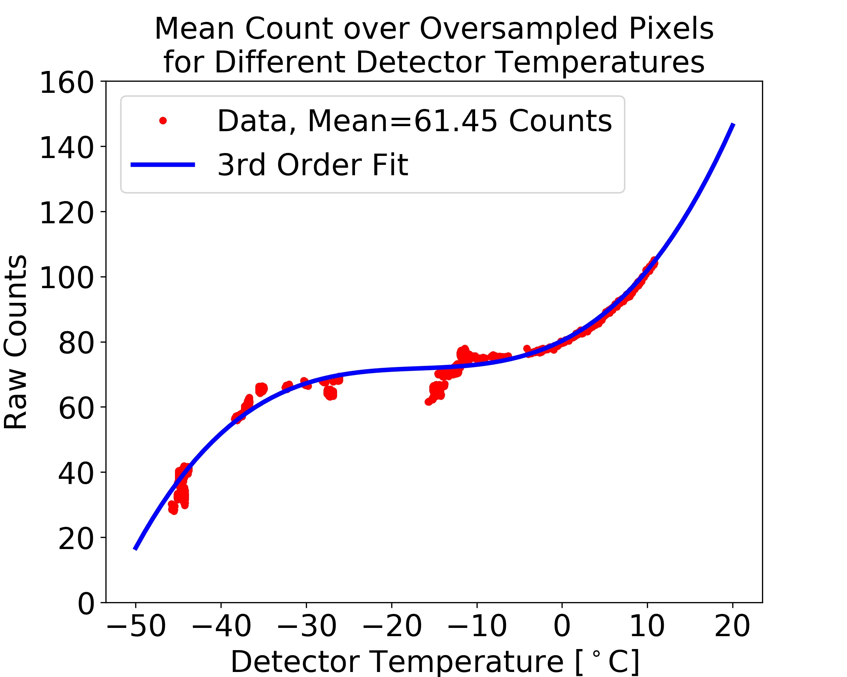
Figure 4.1.1: DO₀ as a function of T_{CCD} measured during CalLM.

All 2048 x 2048 arrays DO_{Ci}, DO_{Ti}, DS_{i} and k_{Si} from equation 1 are shown in figure 4.1.2 as separate panels. DO_{Ci} gives the difference between the dark offset at each pixel and the value DO_{OV} at standard conditions. As seen in figure 4.1.2, DO_{Ci} increases towards the left edge of the detector, probably due to a temperature increase in this direction, and also shows a separation into 4 regions covering a quarter of the CCD each, which we believe is due to some characteristics of the readout electronics. The temperature dependence of the dark offset uses calibration parameters DO_{Ti} and k_{O}. DO_{Ti} is mostly a function of the CCD columns (figure 4.1.2) with k_{O} determined to be 0.166/K.

The dark slope DS uses calibration parameters DS_{i} and k_{Si}. DS_{i} is characterized by an increase at the readout corners due to elevated temperature and also shows a rather small number of hot pixels. Using as a criteria for a hot pixel to exceed the expected value by more than 10 counts at the reference temperature, then EPIC has 210 hot pixels, which is 0.005% of the pixels. Since they are singular isolated pixels, they are not really visible in figure 4.1.2.

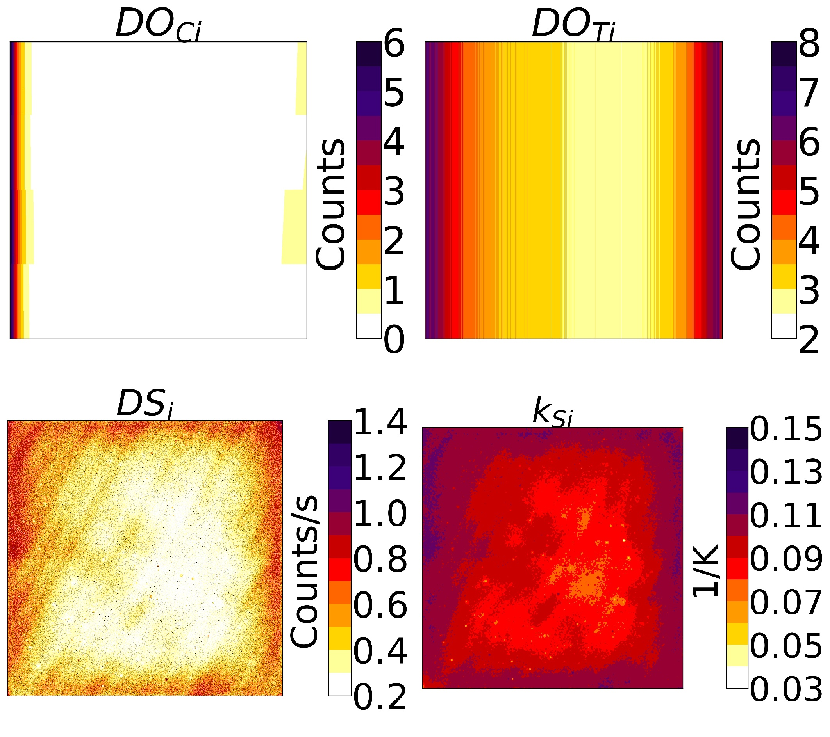
Figure 4.1.2: Dark model parameters DO_{Ci}, DO_{Ti}, DS_{i} and k_{Si} from equation 1.

In the first calibration versions, the “trend term” DO_{T} in equation 1 was not included in the dark model. It was added in 2017, when we discovered some pattern of the true dark count drifting away from the dark model as shown in figure 4.1.3. This effect is clearly temperature-related but is obviously not correctly captured by the T_{CCD}-dependent terms in equation 1, although they have been determined over a wide range of temperatures as seen in figure 4.1.1. It turned out that adjusting the dark model with a modified T_{CCD}-dependence was not really possible, since the relation between the temperature and the observed dark count bias does not “fit” in the dark model framework. The seasonal temperature cycle of ±1.1^{O} K is rather constant over time, while the seasonal cycle in the dark count bias changes from ±0.16 counts in 2015 to > ±0.5 counts in 2020. Furthermore, the seasonal temperature cycle relates to the seasonal dark anomaly cycle on average by ~0.3 counts/K, while the upwards trend in the temperature of ~0.3 K/year causes an upwards trend of the dark count bias of ~0.5 counts/year, i.e. a much higher relation of ~1.7counts/°C. Due to this discrepancy we decided to define DO_{T} as a function of the image acquisition time t_{IM} with seasonal variation and a linear drift as shown in figure 4.1.3. With this addition the dark model again reflects well the true EPIC dark counts over its time in orbit.

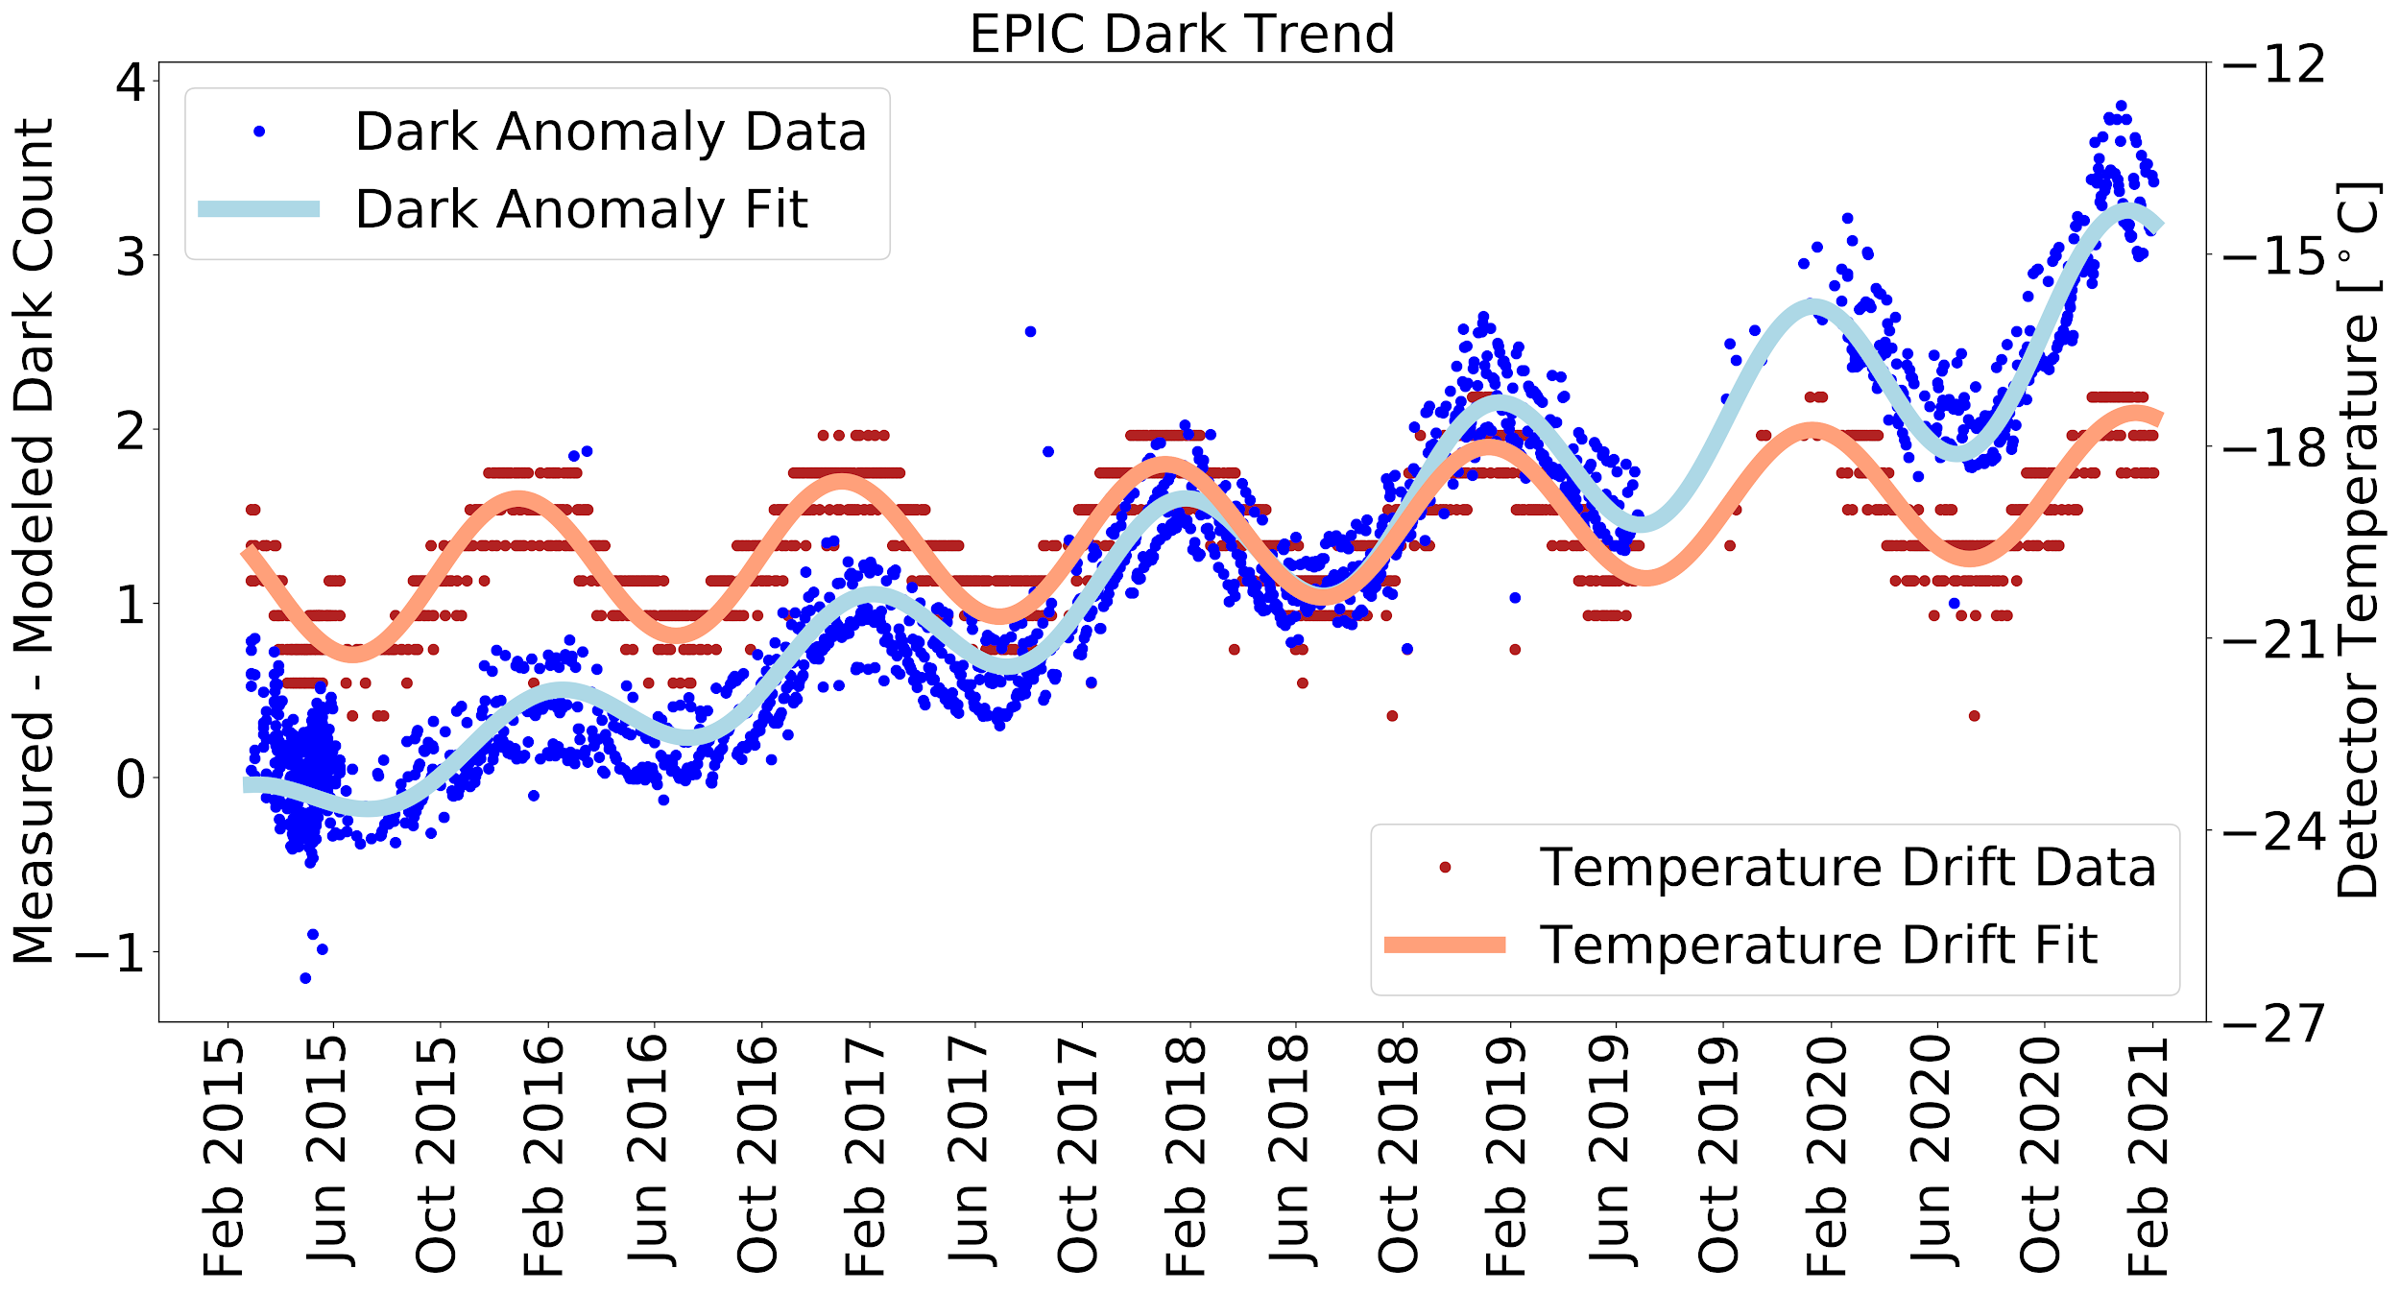

Figure 4.1.3: EPIC dark trend. The apparent noise in the dark anomalies (blue dots) is mostly caused by the low resolution of 0.6 K for the detector temperature readings (red dots). Both data sets are fitted with formula y = a₀ + a₁ · t + ( a₃ + a₅ · t ) · sin[ 2 · 𝜋 · ( t - a₂ ) / a₄ ], where t is the time since 1 Jan 2017 0:00 UTC. The obtained fitting parameters for the Dark Anomaly Fit (blue line) are : a₀ = 0.71 counts, a₁ = 0.49 counts/year, a₂ = 71 days, a₃ = 0.30 counts, a₄ = 359 days, a₅ = 0.07 counts/year. For the Temperature Drift Fit (red line): a₀ = -19.69 °C, a₁ = 0.28 K/y, a₂ = 94 days, a₃ = 1.13 K, a₄ = 368 days, a₅ = -0.02 K/y.

4.2 Enhanced pixel detection
This L1a processing step actually only affects the pixel type array and does not change the L1a data array itself. The raw EPIC data can be saturated or enhanced. The EPIC exposure times (table 2.1) have been adjusted so that saturation hardly occurs, but it can still happen when a pixel is covered by a highly reflective cloud high up in the atmosphere.

Enhanced pixels are pixels with persistent physically impossible values that exceed the values of neighbor pixels by a too large amount. This can be understood when looking at figure 4.9.1, which shows the EPIC point spread function (more in section 4.9). For example, based on this function it is not possible that the value in a pixel is 5 times larger than the average value over adjacent pixels. We believe this enhancement is mostly caused by issues in the readout electronics. Nearly all EPIC images show a small percent of enhanced pixels. Their number varies between just a few such pixels up to around 1000 of them in a single image of 4 million pixels. An algorithm to detect enhanced pixels was developed that marks them in the pixel type array so that they can be ignored for scienc data products.

4.3 Read wave correction
EPIC’s read out electronics add a small sinusoidal wave to the image, called the “Read wave”. This wave goes along the columns of the image, has a rather constant period between 10 and 11 pixels, but varies from image to image in amplitude (between 0 and 0.6 counts) and phase. Both amplitude and phase are approximately constant for all rows. An example of such a read wave is shown in figure 4.3.1. We developed an algorithm to determine the amplitude and phase of the wave for each measurement, so that the read wave can be subtracted from the data.

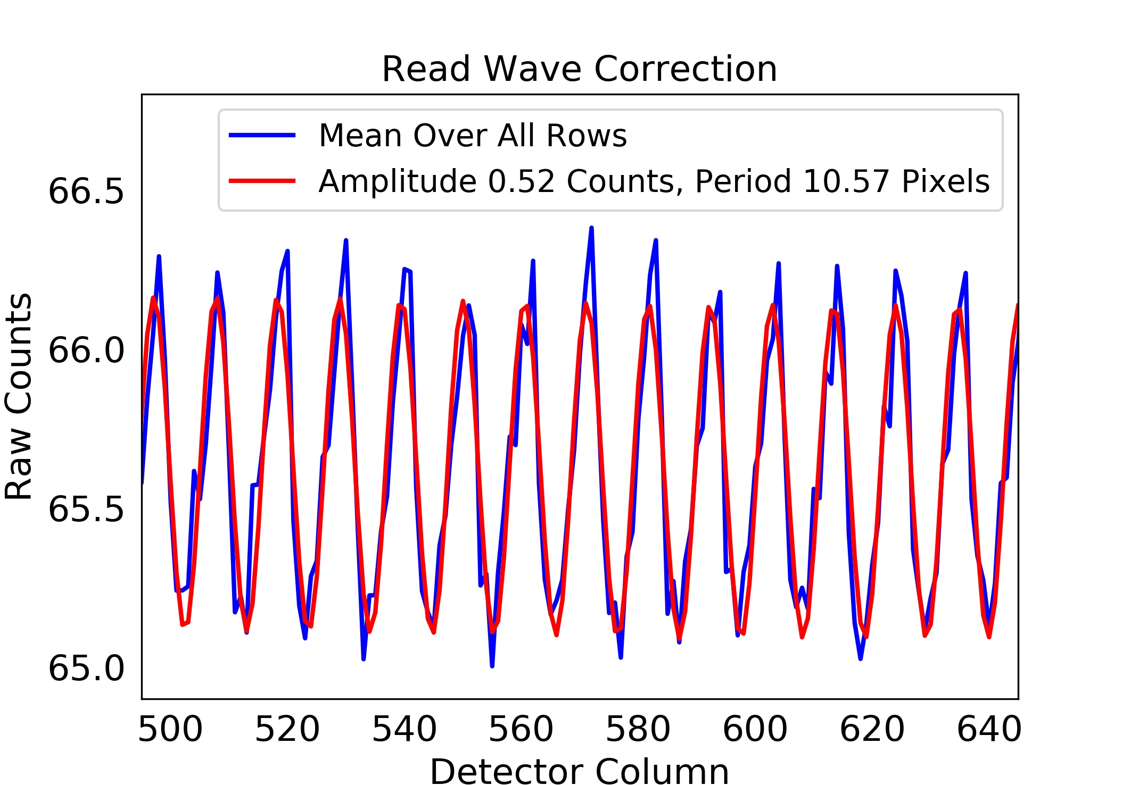
Figure 4.3.1: Example for read wave for a dark count measurement. The blue line shows the average of the counts over all CCD rows between columns 495 and 645. The red line is a fitted sinusoidal wave, which is subtracted from the image for the read wave correction.

4.4 Latency correction
Just like many imaging devices with a CCD, EPIC suffers from a so-called “latency effect”. That is, pixels with low signal level are significantly biased high when they are read after a large number of pixels with high signal level. This can cause an overestimation of as much as 12% in the signal from a clear scene on Earth, if it happens to be adjacent to an extended region of clouds that is read just before it. The consequences of this bias have been analyzed for other satellite instruments [Várnai and Marshak, 2009].

Luckily the EPIC detector can be drained from two opposite corners, which allowed us to characterize this effect and develop a correction method for it. The method determines the additional charge Δ_{i}, which is accumulated in the readout electronics and added to the “true” signal C_{i}, which is the charge originating from the measured photons. We assume Δ_{i}=0 for the first pixel i=1 to be read, and for each subsequent pixel i+1 Δ_{i+1} is given by equation 2:

(Equ 2) Δ_{i+1} = Δ_{i} · ( 1 - k_{D} ) + C_{i} · k_{G}

k_{G} and k_{D} are the latent charge gain and decay constants respectively and have been determined to k_{G}=8.6x10⁻⁶ and k_{D}=3.7x10⁻³ for the regular readout mode based on measurements during CalLM. The effect is illustrated in figure 4.4.1. Use of Eqn. 2 reduces latency errors by about a factor of 3.
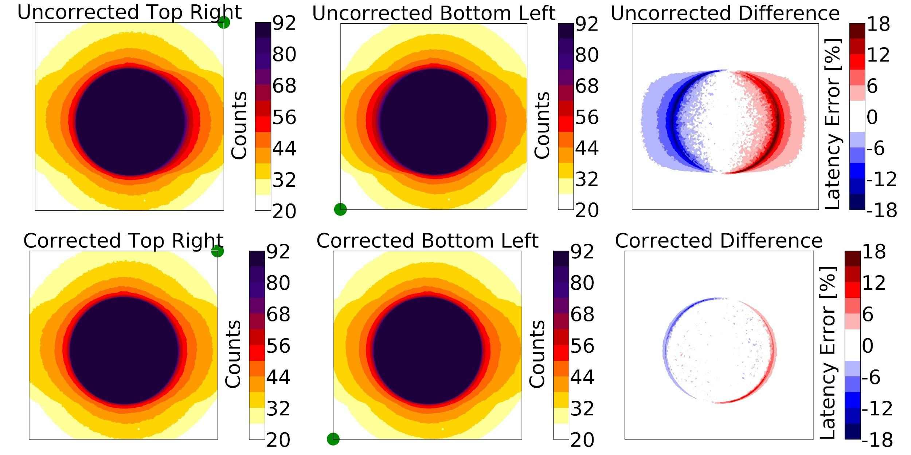

Figure 4.4.1: Illustration of EPIC latency effect using measurements from CalLM. The exactly identical illumination, a circular illumination with a radius of 560 pixels, has been measured with two readout modes. One drains the image at the top right corner (see green dot in left panels), the other at the bottom left corner (see green dot in center panels). The latency effect adds a positive bias to the data read just after the target, i.e. at the right side of the detector in the top left panel and at the left side in the top center panel. The top right panel shows the percentage difference of the panels (Top Right Corner minus Bottom Left Corner) before applying the latency correction. The bottom panels show the same images after the latency correction has been applied.

4.5 Non-linearity correction
EPIC readout electronics underestimate very small (<500 counts) and very high signal levels (>3500 counts) by up to 0.2% (see figure 4.5.1). This is a relatively small non-linearity effect and was characterized during CalGSFC.

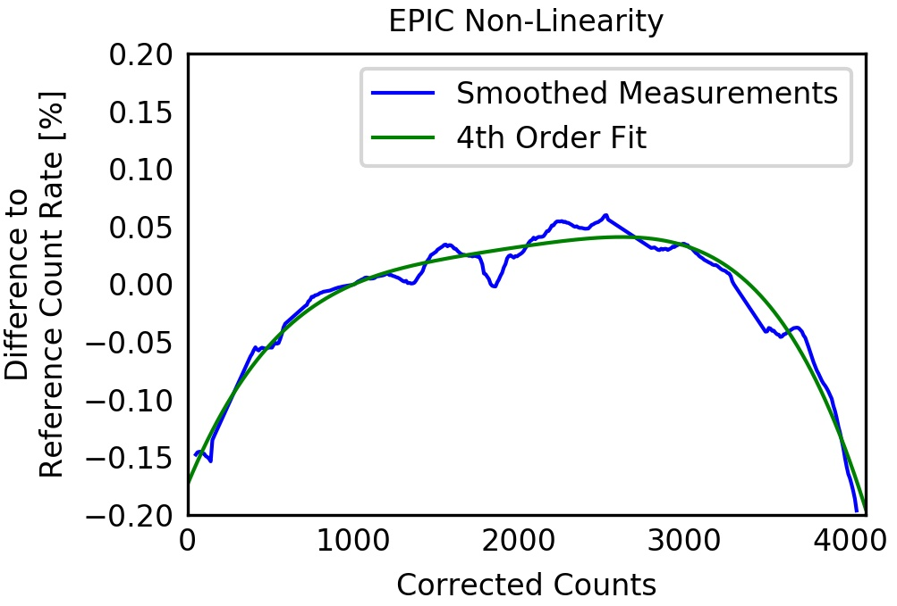
Figure 4.5.1: Measured (blue) and fitted (green) non-linearity of EPIC based on laboratory measurements during CalGSFC.

4.6 Temperature correction
EPIC shows a small radiometric temperature sensitivity of 0.01%/K (figure 4.6.1), which is corrected in this step by using the on-board reading of the detector temperature. It was calibrated during CalGSFC, where images from a constant light source were taken over a temperature range from -40 to -10°C.

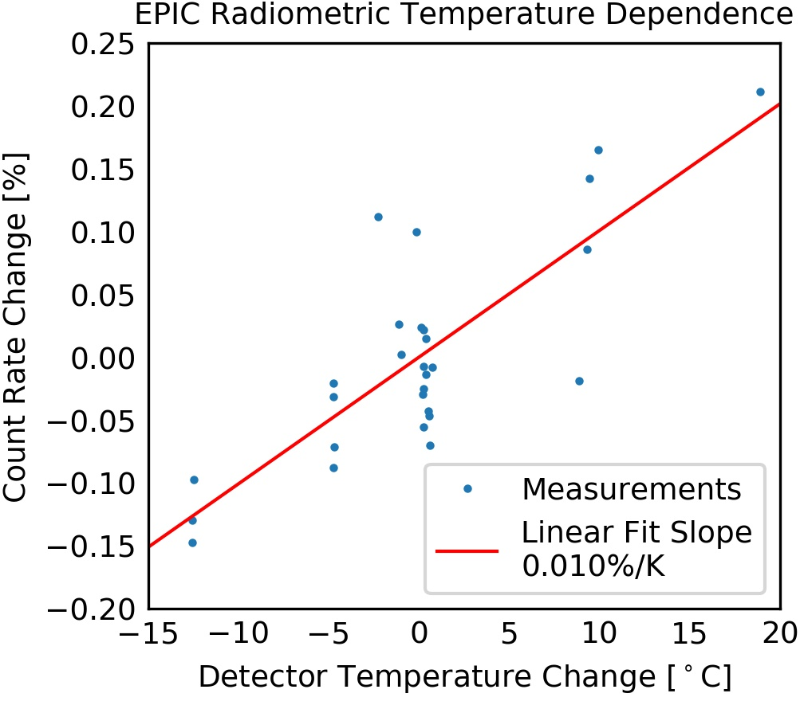
Figure 4.6.1: Measured and linearly fitted radiometric temperature sensitivity of EPIC based on laboratory measurements during CalGSFC.

4.7 Conversion to count rates
The exposure time of an EPIC image is determined by the shutter, which is a rotating disk with three open sectors of different angular widths that moves to unblock the incoming light beam [Atmospheric Data Science Center, 2016]. Use of the smallest sector (exposure < 10 ms) is slightly non-linear because of acceleration effects. This means that different pixels are exposed to light for a different amount of time. Use of the wider sectors for longer exposures (> 10 ms) makes this shutter effect negligible (see table 2.1). In this conversion step the total counts are divided by the exposure time to convert from corrected counts to corrected count rates (counts/sec).

4.8 Flat fielding
When EPIC is illuminated by a uniform input (i.e. each pixel receives exactly the same signal), the recorded image lacks uniformity for several possible reasons:

- Pixel response non-uniformity (PRNU): this is caused by small variations in the sensitivity of each pixel. It is independent of wavelength, has very small spatial extent (i.e. changes from pixel to pixel), and a magnitude in the order of a few percent.
- Etaloning (ETAL): this is caused by optical interference effects from thickness variations in the depletion region of the CCD. It only affects longer wavelengths above 600nm (filters 7 to 10), has a wider spatial extent than PRNU, and a magnitude of tens of percent.
- Surface inhomogeneity (INHOMO): this is caused by inhomogeneities on the detector surface, especially from the hafnium coating. It manifests as a localized reduction or enhancement of the sensitivity for a group of pixels with a magnitude of tens of percent. It has the same distribution, but different magnitude for different channels (usually stronger effect in the UV than in the visible, since hafnium is nearly transparent in the visible and NIR). The affected regions can have very different spatial extensions. Some features affect only a few pixels, while others spread over hundreds of pixels.
- Vignetting (VIGN): this is the reduction of the instrument sensitivity towards the periphery of the field of view. VIGN varies smoothly across the CCD and might be different for different filters. Based on optical modeling of the telescope EPIC should not have strong VIGN, at most in the order of a few percent.

In both pre-launch calibration campaigns CalLM and CalGSFC we attempted to produce an illumination as uniform as possible across the CCD. The setup during CalLM is shown in figure 3.1, where the beam reaching EPIC was the output of a Dobson collimator telescope (Fig. 3.1). In CalGSFC, EPIC was looking onto a large diffuser plate, which was illuminated by a high-power tungsten halogen lamp. However, both inputs were far from being “flat” and showed gradients up to 30%. This forced us to accept some compromises for the pre-launch flat-field calibration.

We split the PRNU from the other effects described above, since it does not really need a flat input as long as the signal varies smoothly and slowly across the detector. It can be derived by comparing the value at a single pixel to the average value of the surrounding pixels. The final PRNU array is shown in figure 4.8.1. It is applied separately from the other flat-field effects in the L1a data correction. We do not expect the PRNU to change over the lifetime of the mission.

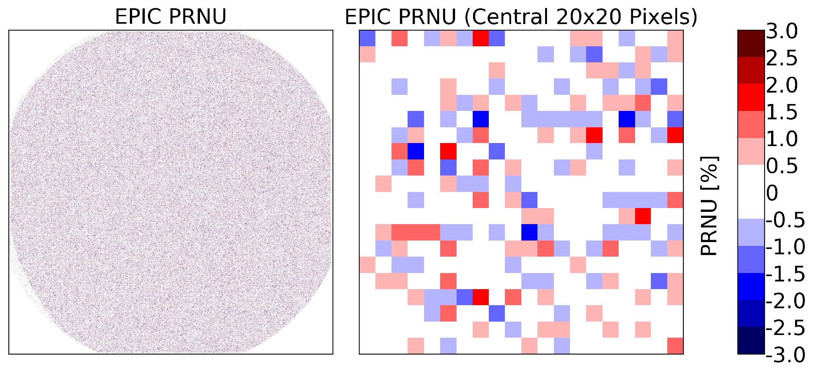
Figure 4.8.1: EPIC Pixel response non uniformity as determined during CalGSFC. 61% of the pixels inside the telescopes’s FOV have an absolute value of the PRNU below 0.5%, 30% between 0.5 and 1.0% , 8% between 1.0 and 1.5%, 1% between 1.5 and 2.0% and 0.1% above 2.0%.

Instead of getting the absolute numbers for ETAL, INHOMO and VIGN we derived the combined result from these three effects relative to the green filter 6, for which no flat field correction other than the PRNU was assumed or needed. The result of this “relative” pre-launch flat field calibration is shown in figure 4.8.2. The reason we picked filter 6 is that it is not affected by ETAL and we also observed very little INHOMO. In this way it was possible to cancel out that part of the inhomogeneity of the input beam, which affects all filters in the same way.

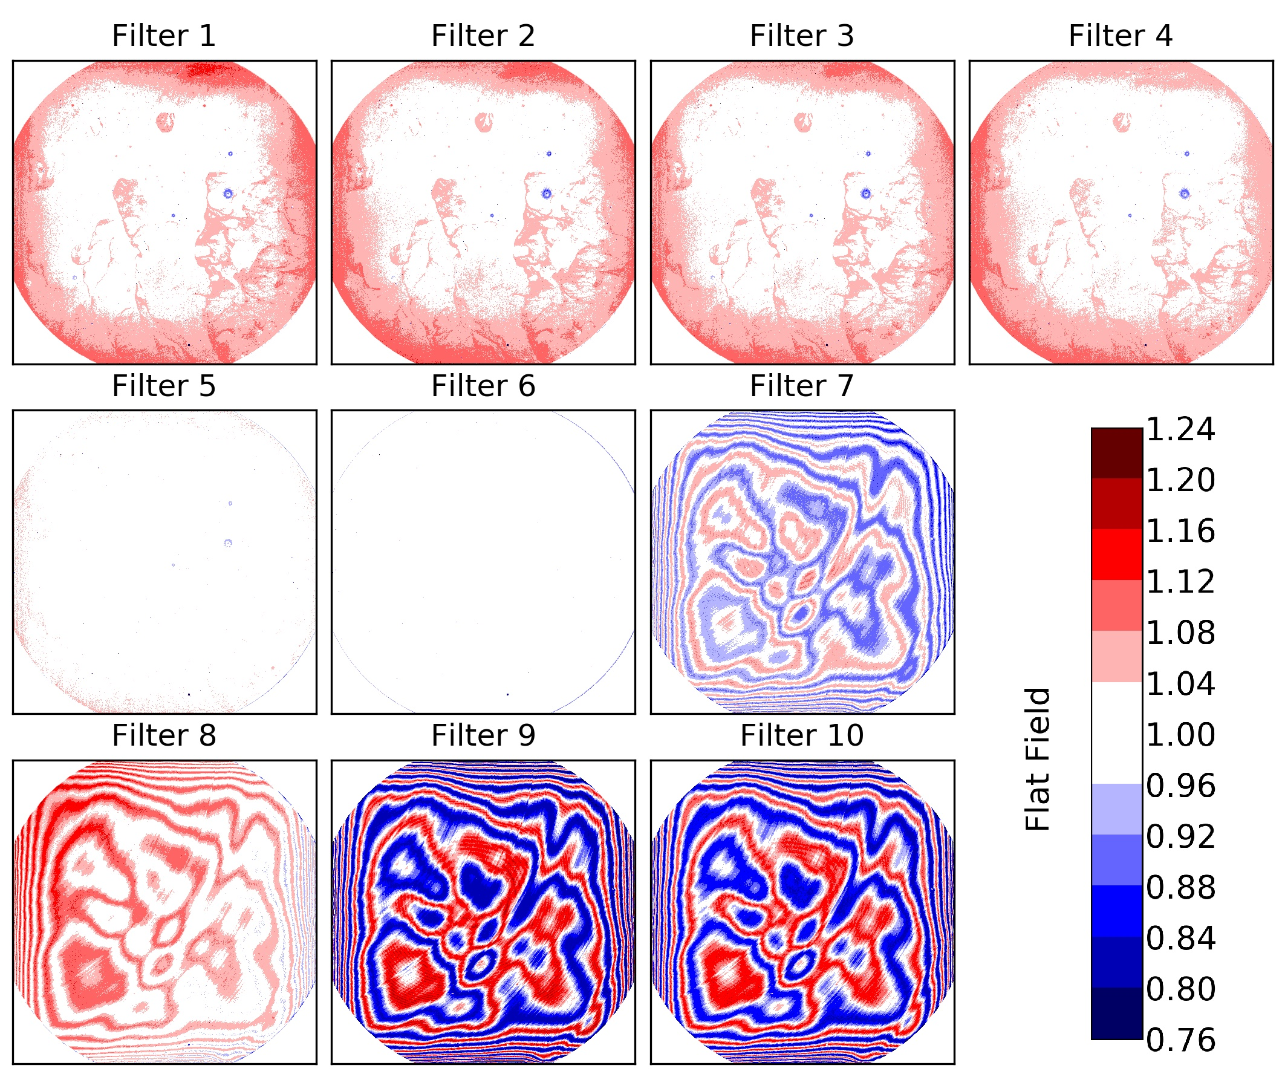
Figure 4.8.2: EPIC flat field maps without PRNU based on the results from CalGSFC.

We can observe in figure 4.8.2 that filters 1 to 5 are dominated by INHOMO, while filters 7 to 10 are dominated by ETAL. Overall the flat field correction for EPIC is huge, on the order of ±25%. The magnitude of INHOMO was significantly different between CalLM and CalGSFC. We believe this is partly caused by the uncertainty in the laboratory measurements itself, but also originates from changes on the detector surface over pre-launch time from 2011 to 2014. We used the results from CalGSFC for the final pre-launch flat field correction, as they were closer to the launch date (2015). Due to these difficulties in the flat field calibration and the resulting large uncertainty, the plan was to re-evaluate and possibly modify the flat-field correction using in-flight data.

A first modification of the flat field calibration was performed in Fall 2016 using the fact that the telescope rotates about its optical axis with a six-month period. The idea was that when we average all the images of one filter over a long period of time, we should obtain a rather smooth image, since all features caused by the atmosphere and the ground should average out as they are “moving” across the detector. We saw that this assumption holds for small features, i.e. the resulting averaged image is rather smooth, but there are still systematic effects that cause an inhomogeneous result. For example, there are ocean glint, which creates an enhancement in the center of the Earth [Marshak and Knyazikhin, 2017], and high albedo regions of Greenland and Antarctica, which cause higher backscattered signal away from the center of the image as they are at high latitudes. Therefore, we again fixed the flat field in filter 6 and only looked at the differences from it with this technique. The in-flight version of the flat field correction differed on average from the 1st version by <0.03% for filters 1-5, and in the range of 0.3-0.5% for filters 7, 9, and 10. However, in all filters there were extreme values, where the flat field changed for certain pixels by 34-53% in filters 1-5, and 9-15% for filters 7, 9, and 10. The technique did not seem to improve the flat field for filter 8 and therefore that channel was left unchanged. As a result of this improvement, L2 data such as the total ozone columns gave much smoother and consistent results (see figure 4.8.6, left and middle panel).

The next improvement was to compare EPIC measured radiances for filters 1 to 5 with collocated radiance data from the NASA Ozone Mapping and Profiler Suite (OMPS) satellite [National Oceanic and Atmospheric Administration, 2021]. The radiance comparisons were done for identical geograpohic locations seen at the same GMT and with the same solar zenith angles (SZA) and viewing angles (VZA) within a tight tolerance. This enables the measures radiances in counts/sec to be converted into proper radiance units (W m⁻² sr⁻¹) or to top of the atmosphere Earth albedo.

Short description of what was done by Huang.

Finally, we estimated the magnitude of VIGN from the lunar measurements during CalMoon. After correcting for the slightly changing distances Sun-Moon-EPIC, a given face of the Moon can be considered a stable light source. The obtained results for the EPIC sensitivity decrease towards the edge of the FOV are shown in figure 4.8.3. Since the scatter in the results was significantly larger than potential differences among the filters, we used a polynomial fit on the average over all filters as the final function for VIGN (black line in figure 4.8.3). The lunar calibration measurements are periodically repeated over the life of the mission.

The actual flat field maps are shown in figure 4.8.4 and the difference to the pre-launch version in figure 4.8.5. This further improved the quality of the L2 data like total ozone columns (see figure 4.8.6, right panel).

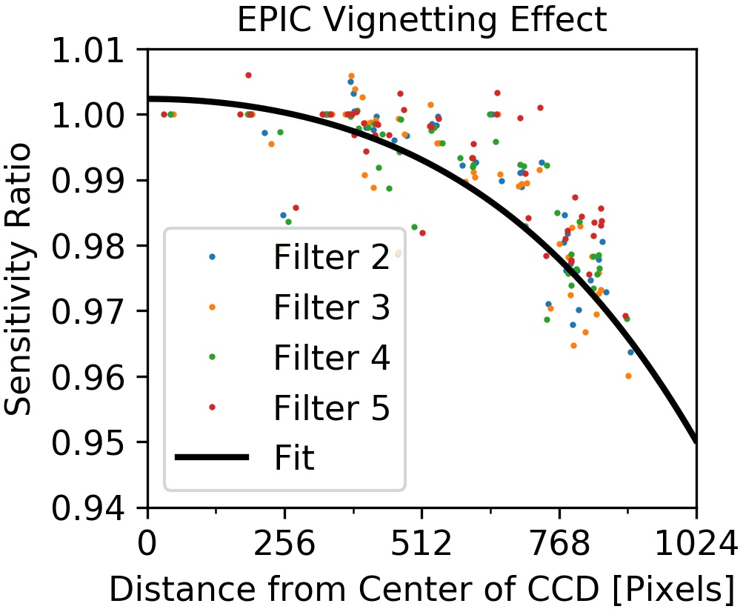

Figure 4.8.3: EPIC VIGN effect estimated from lunar observations during CalMoon. Each dot is the result of a single lunar image for the respective filter. The black line is a polynomial fit in all the data.
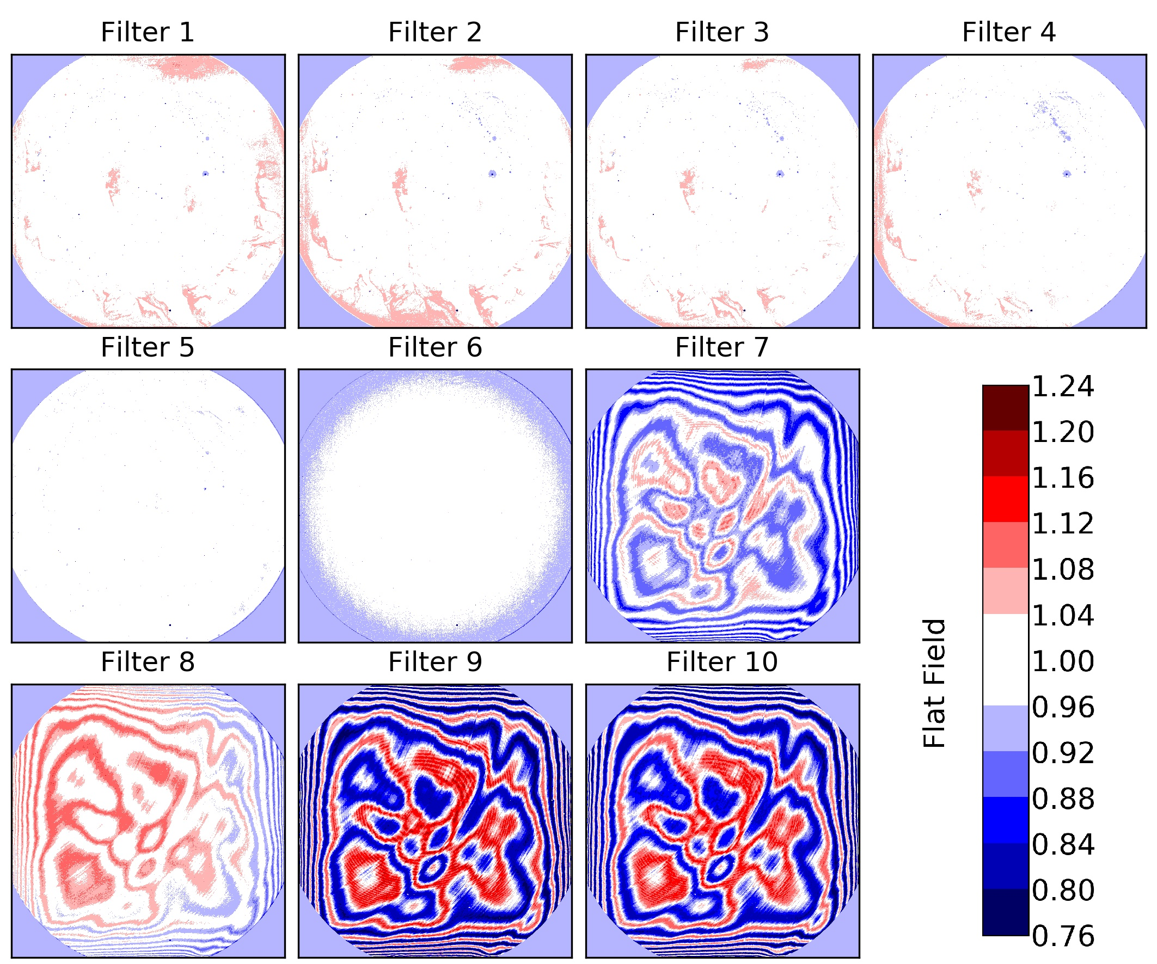
Figure 4.8.4: EPIC flat field maps without PRNU from the actual calibration version 18.

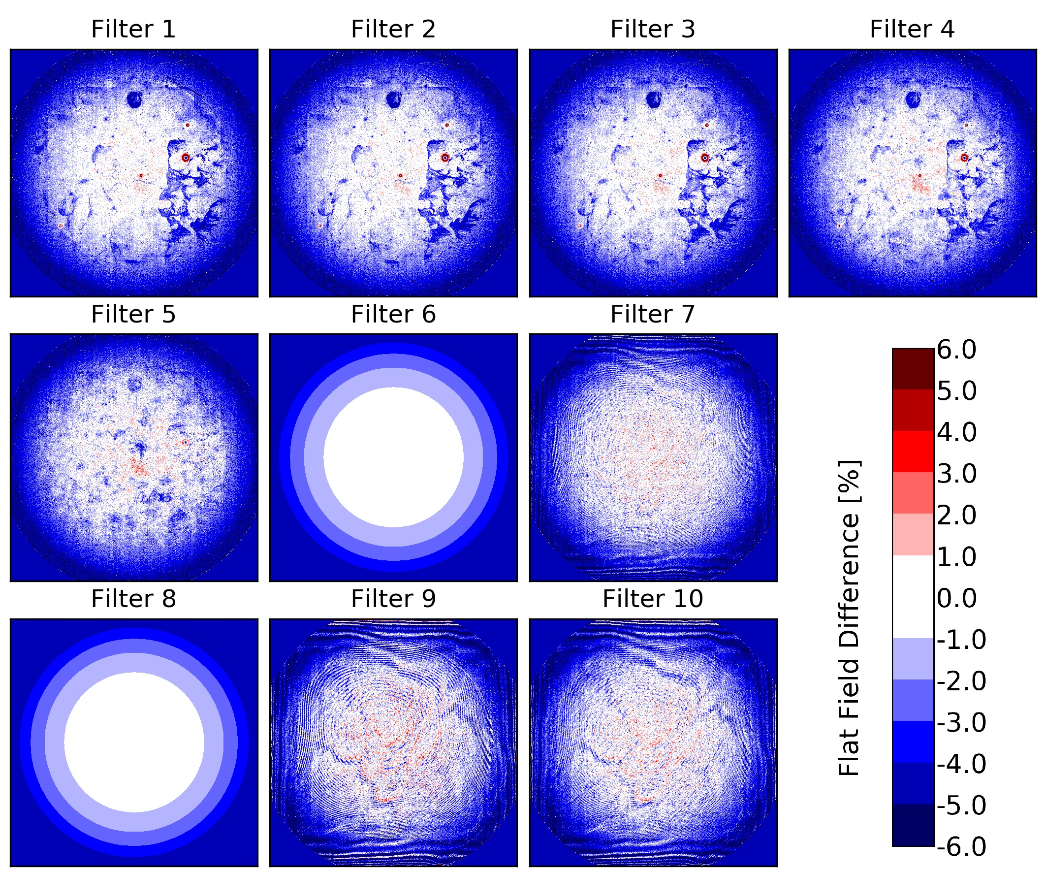
Figure 4.8.5: Percentage difference between flat field maps from the initial version (figure 4.8.2) and the current version (figure 4.8.4).

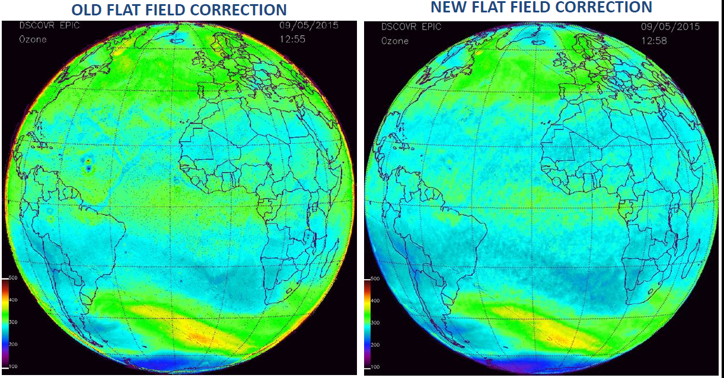

Figure 4.8.6: EPIC total ozone columns on DD MMM YEAR at HH:MM UTC using flat field calibration from pre-launch (left panel), the update from Fall 2016 (middle panel) and the actual latest version (right panel).

4.9 Stray light correction
The light entering EPIC from a specific direction does not only end up at the CCD location defined by geometric optics, the “core region” for the corresponding pixel and its neighbor pixels defined by the point-spread function. A fraction of the light is distributed over the entire detector as stray light. The fraction of the total signal ending up outside the core region, the “stray light fraction”, is rather large for EPIC, between 12 and 20% depending on the filter (see table 2.1). If not corrected, the stray light would severely reduce the quality of the scientific data products, particularly those depending on the ratio of light from different wavelength channels. Therefore, a stray light correction method based on the knowledge of the instrument’s point spread function (PSF) was developed. The method follows the method described in Zong et al. [2006] used for a different purpose. To our knowledge this is the first time that such a technique has been applied to a 2-dimensional detector. Our novel approach is described in this section.

As mentioned in section 3, different targets were used during CalLM to create different illuminations for EPIC. For example, one target produced the circular image seen in figure 4.4.1. Another target produced a quasi-parallel beam with divergence of ±5x10⁻⁵ degrees, which is only one third of the angular extension of one pixel, 3x10⁻⁴ degrees. When this “sub-pixel-illumination” was positioned to reach the CCD right in the center of a pixel, the obtained signal from adjacent pixels can be considered to be the PSF of EPIC (figure 4.9.1). Within the measurement uncertainty, the shape of the PSF for EPIC in the core region was found independent of the filter and the position on the detector.
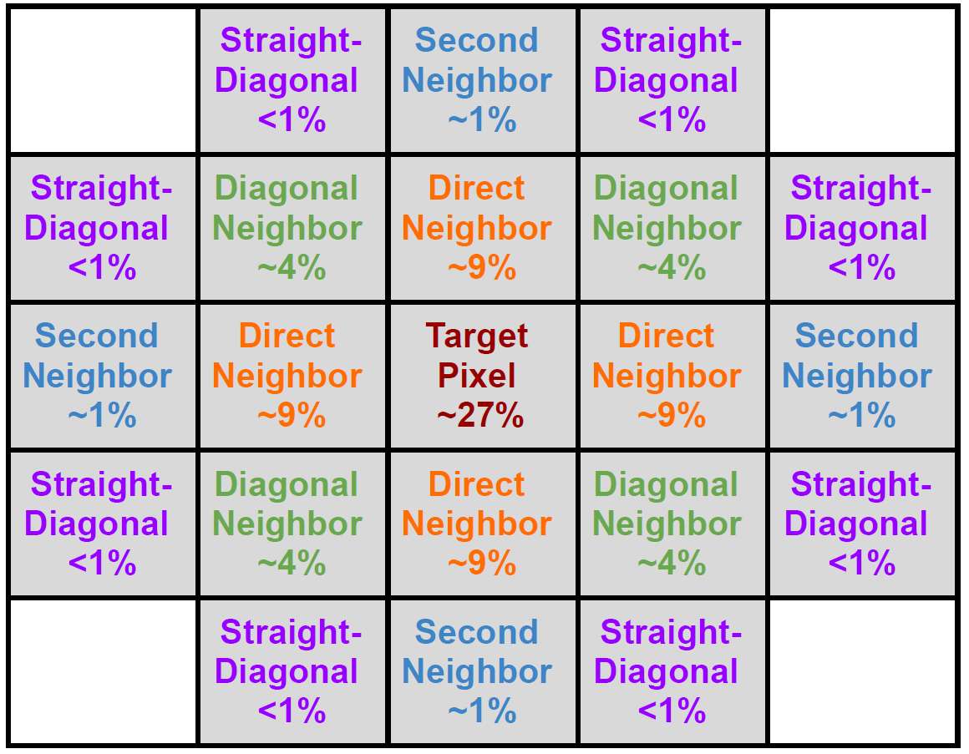
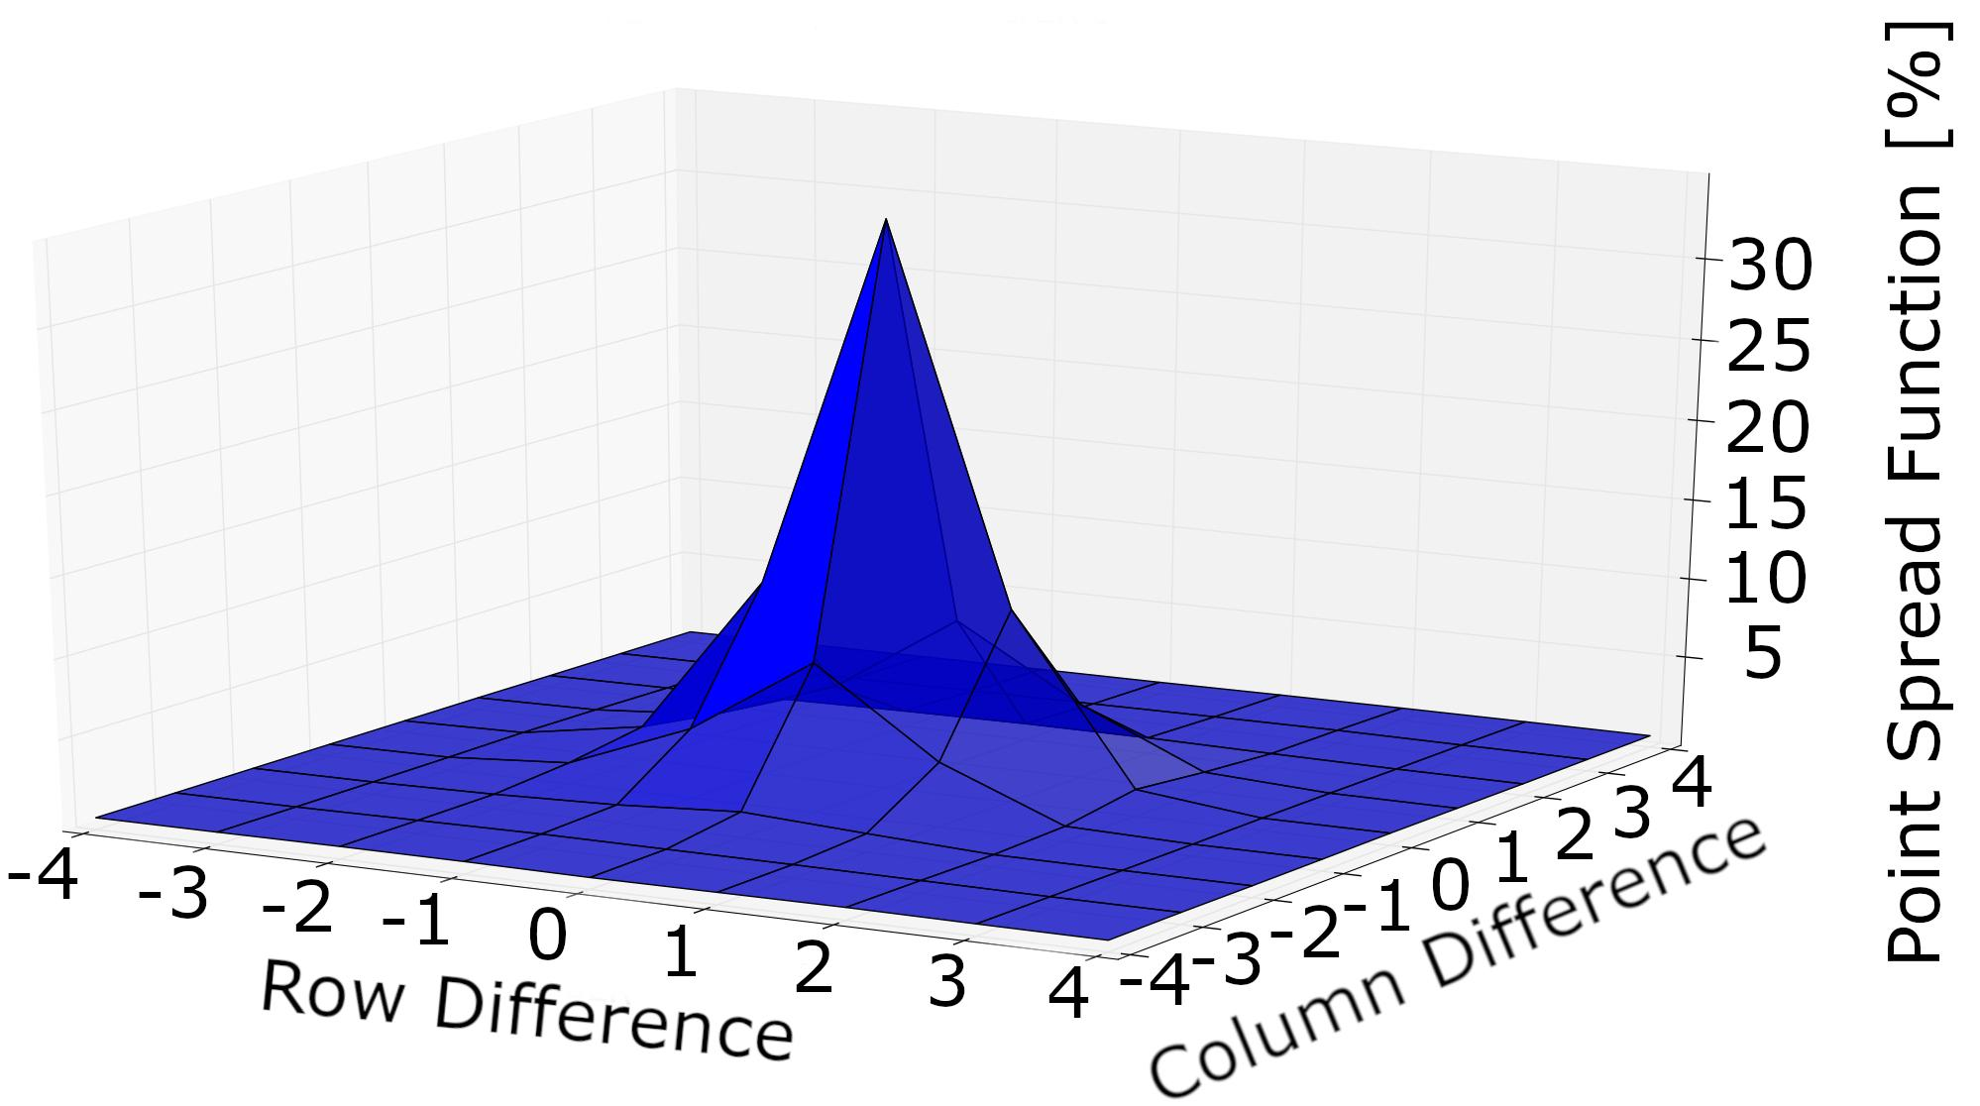
Figure 4.9.1: EPIC PSF in the core region measured during CalLM for filter 6 using sub-pixel-illumination. The data are normalized to the sum of the signal over the entire detector. The individual values are listed in the left panel. For filter 6, 87% of the signal ends up in the core region, i.e. the center pixel and the next neighbor pixels (cells with gray background), while 13% of the signal is stray light and spreads over the remaining part of the CCD. For other filters the shape of the PSF in the core region is the same, but the normalized values are different due to a different stray light fraction (see table 2.1).

When using the sub-pixel-illumination, the signal outside the core region basically disappears in the measurement noise, i.e. the exact structure of the stray light cannot be determined. It was also not possible to increase the exposure time and saturate the center pixel to such an extent that this structure was seen. To solve this problem another target was used, which produces a beam with divergence of ±3x10⁻³ degrees or 3600 times more energy than the sub-pixel illumination. This results in a “small circular image” with a radius of 20 pixels. Both unsaturated and saturated measurements with this target were taken and then merged to produce final images, which are shown in figures 4.9.2 and 4.9.3. As in figure 4.9.1 the data are normalized to the sum of the signal over the entire detector. Several common features can be seen in the figures. However, not all of them are related to stray light. For example, we believe that the enhancement of the entire rows in the saturated regions is due to a not fully removed readout latency effect.

The most obvious feature of the EPIC stray light is a ghost image, in which the support structure of the secondary mirror can be seen. Based on optical modeling, we think this ghost image is mainly caused by reflections between the detector and the parallel filters, which are significant, although all of these optical elements have proper anti-reflection coatings applied. Since filter wheel 1 is farther away from the detector, the diameter of the ghost image is larger for filters 1 to 5 than for filters 6 to 10 (see figure 4.9.3).

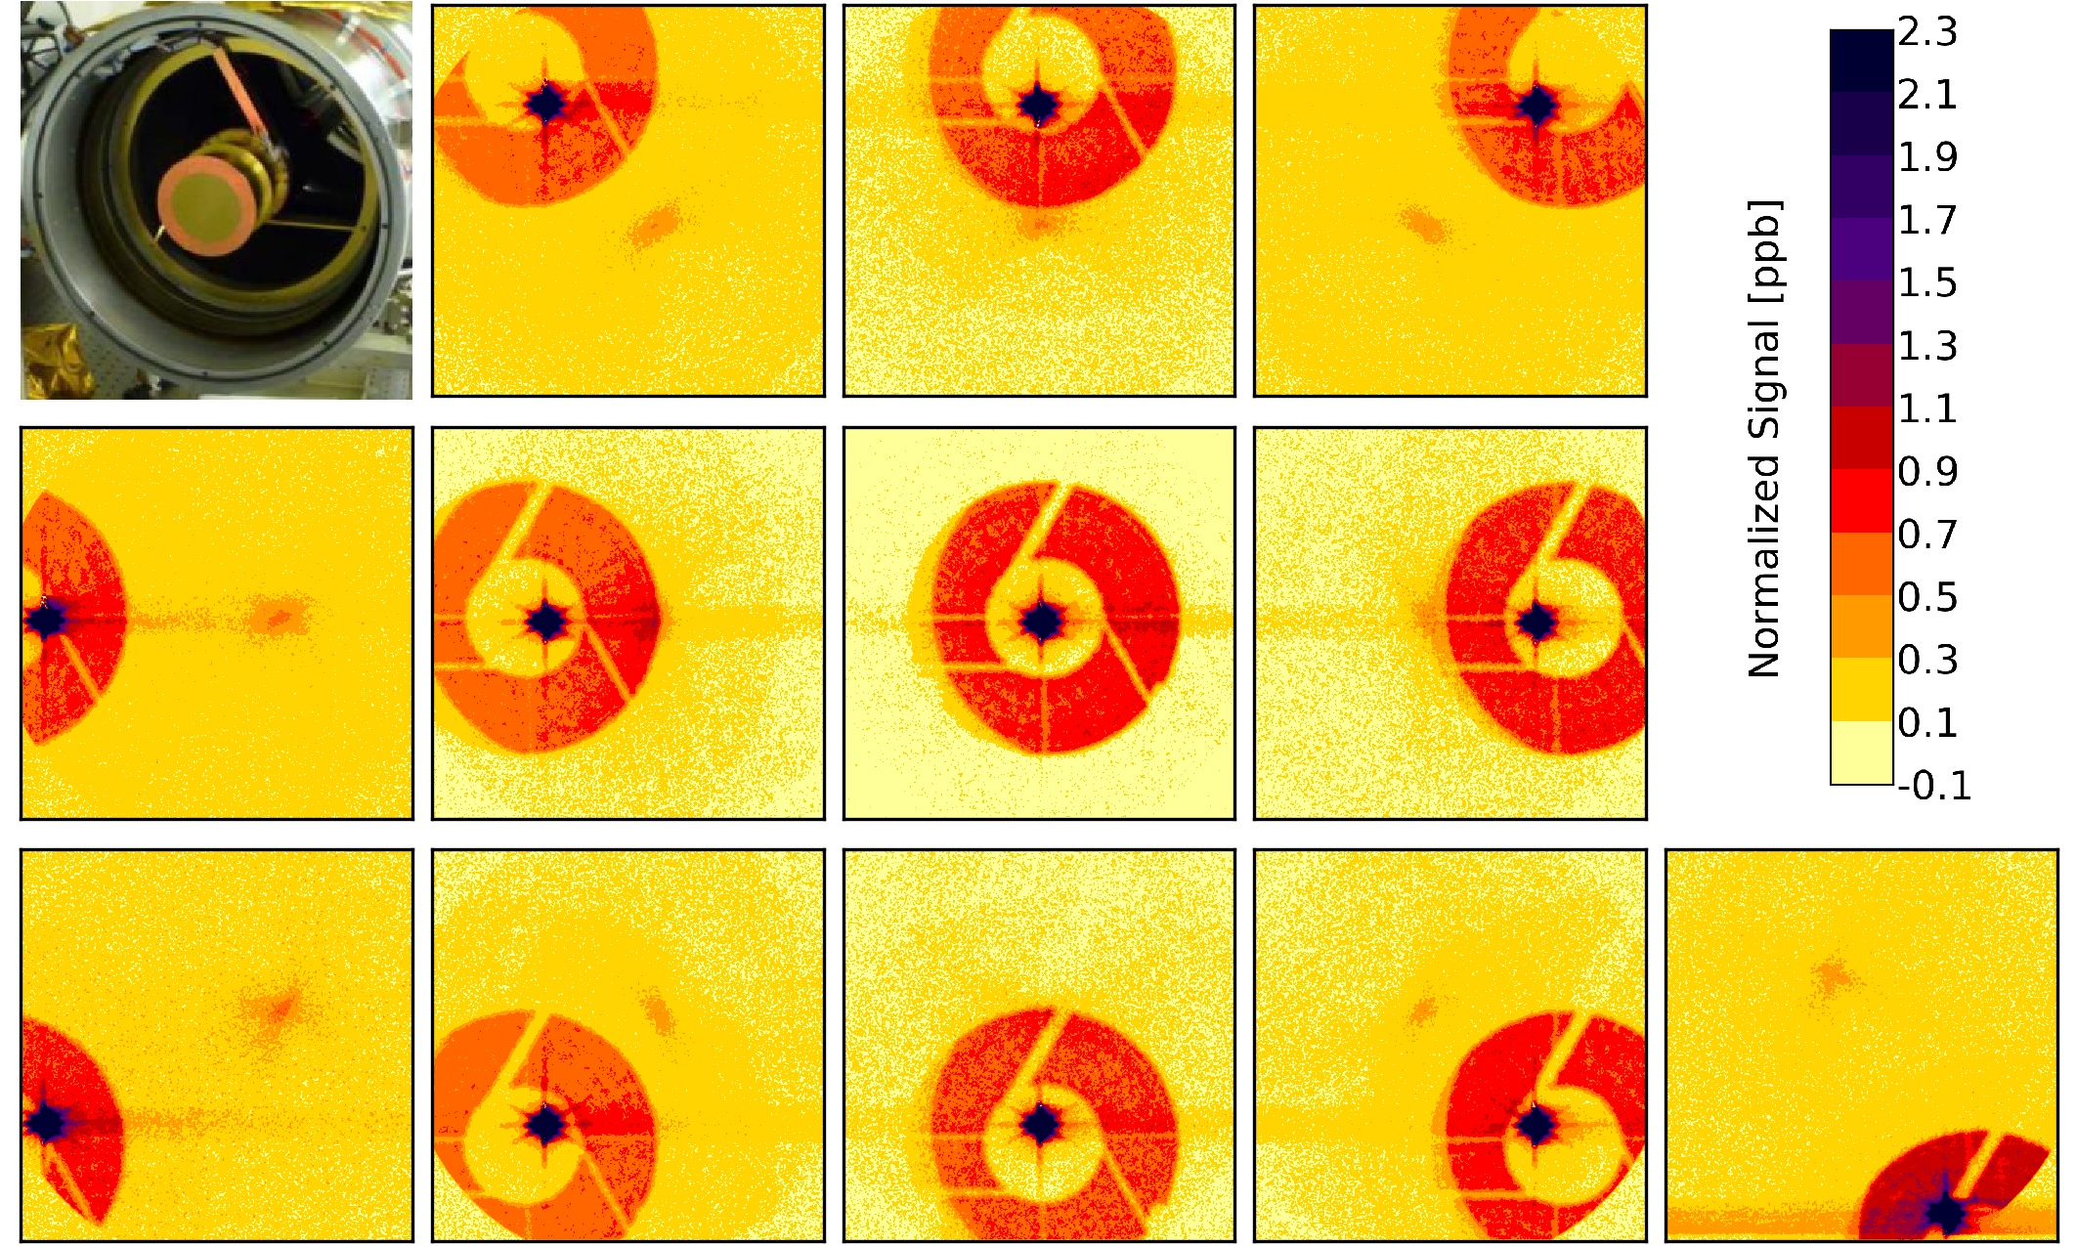
Figure 4.9.2: EPIC PSF measured during CalLM for filter 8 using the small circular illumination directed at different positions on the detector. The top left panel shows the entrance of EPIC with the support structure of the secondary mirror.

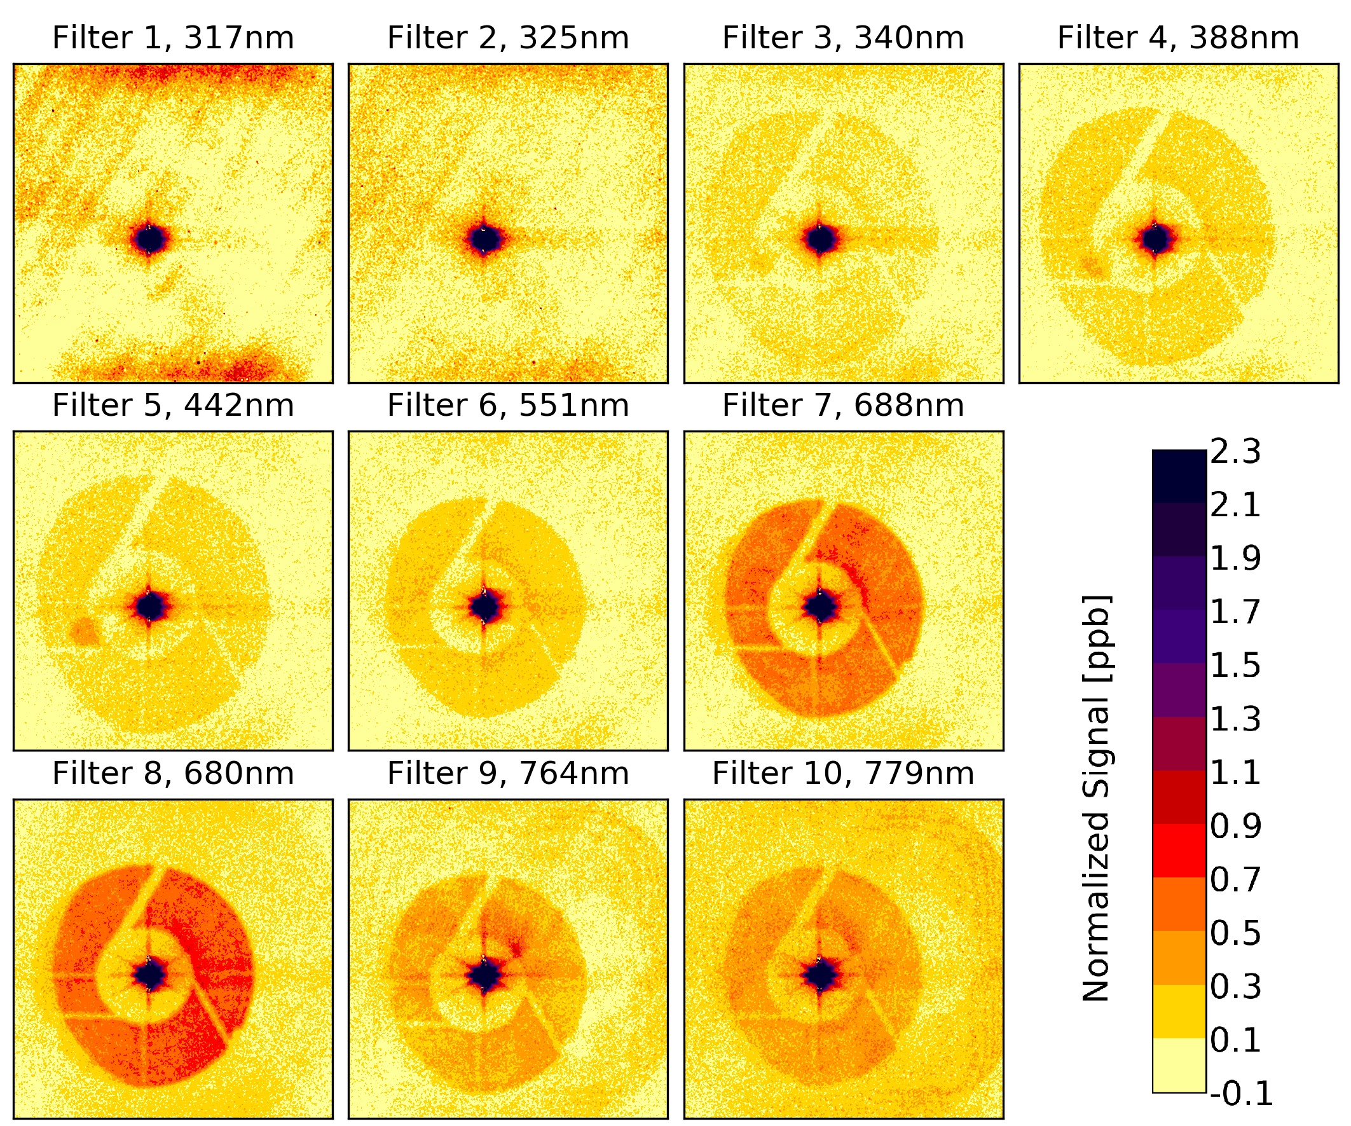
Figure 4.9.3: EPIC PSF measured during CalLM using the small circular illumination directed at the center of the detector for all filters.

Based on these measurements we developed a PSF-model for EPIC. For this model the PSF was divided into 8 different “regions”: the core region with the 21 pixels shown in figure 4.9.1, the near field, transition and interpolation regions, extending to a distance of ~200 pixels around the center pixel (violet and dark red colors in the figures), the ghost image region (mostly orange colors in figure 4.9.2), the regions inside and outside of the ghost (mostly yellow) and the region outside the telescope (the gray corners of figure 2.3). The PSF-model consists of a set of filter-dependent parameters for each region, e.g. the stray light level in the transition region or the diameter of the ghost image region etc. Details such as the arms of the support structure of the secondary mirror were omitted in the model (see also figure 4.9.4). The PSF-model allows us to calculate an estimation of the EPIC PSF for each of the 10 filters for any of the more than 4 million pixels on the CCD.

The next step in the stray light correction method described by Zong et al. [2006] is to build the so-called stray light distribution matrix D, which is basically the combination of all the PSFs. One column of D is the PSF with the core region replaced by zeros for the respective pixel as a column vector, i.e. with dimension (4194304,1) instead of (2048,2048). The unitary matrix Ⅰ is added to D. The result, Ⅰ+D, is a diagonally dominant matrix with ones in the main diagonal and very small numbers elsewhere (values as shown in figures 4.9.2 and 4.9.3). Ⅰ+D is inverted to obtain the stray light correction matrix C (equation 3).

(Equ3) C = ( Ⅰ + D ) ⁻¹ = Ⅰ - D + ½ · D² - … ~ Ⅰ - D*

C is then applied to the measured data (as a column vector) to correct for the stray light. The problem we faced is that for a 2D-detector like EPIC matrices D and C are huge with dimension (4194304,4194304). Such a matrix would occupy >70TB of disk space (for each filter) if stored in single precision. Hence while it is in theory possible to create D using our PSF-model, it is impactable to invert D even with the most advanced computer system available to the DSCOVR project. And even if we were able to perform this inversion, applying matrix C to an image would also take far too much time to be executed for routine operations. Therefore, we made two simplifications:

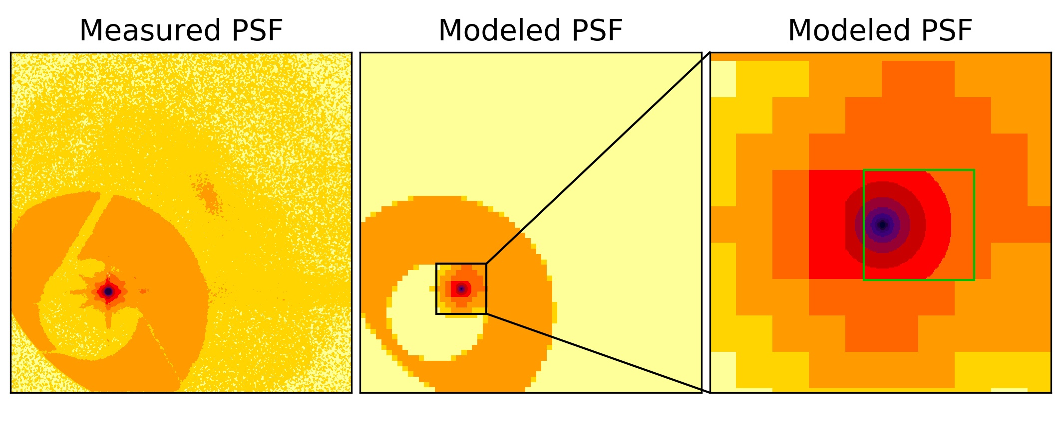
Figure 4.9.4: Measured (left panel, which is the same as the 2nd panel in bottom row of figure 4.9.2) and modeled partially binned PSF (middle and right panels) for filter 8 at target pixel (1400,600) in logarithmic scale. The right panel is a zoom into the middle panel for the region of rows 1250 to 1550 and columns 450 to 750. The area inside the green frame in the right panel is the central part of 96x96 pixels around the target pixel, which is resolved in full resolution. Outside the green frame are the 32x32 “super-pixels”.

First, we applied “partial binning” on the PSFs. The central part of 96x96 pixels around the target pixel is saved in full resolution, but all the pixels outside this central part are binned into “super-pixels” with a size of 32x32 pixels each. An example for this binned PSF is shown in figure 4.9.4. The specific numbers for the configuration of the central part and the binning were a compromise between reducing the size of matrix C as much as possible and still maintaining a good measure of the stray light correction. With these settings the partially binned PSF has a total of 13303 entries (9216 pixels in the central part and in addition 4087 super-pixels), which means the final stray light correction matrix C occupies ~208GB of disk space per filter in single precision. Despite this simplification, the operational stray light correction would still take a long time (roughly 52 minutes per image) when executed on a desktop computer. Instead, the operational EPIC data processing is done on a supercomputer at the NASA Center for Climate Simulation (NCCS) [National Aeronautics and Space Administration, 2021], where the processing can be done in less than 30 seconds per image.

The second simplification is that we approximate the inversion in equation 3 with only the first term of a Taylor series expansion, which can directly be obtained from the PSF-model. In order to compensate for the underestimation caused by the approximation Ⅰ - D, we created a modified distribution matrix D* (equation 3). D* was obtained by testing the stray light correction on pre-launch and post-launch data with known signal input.

One example of such test images is shown in figure 4.9.5, where another target used during CalLM, the “bar target”, is measured. This target consists of rectangular areas with gaps in between. Knowing that the signal outside and in between the openings must be zero, we could fine tune our PSF-model. These images were especially useful to test the performance of the stray light correction in the regions near the central pixel (the near field, transition and interpolation regions), which is something that cannot really be verified after launch.

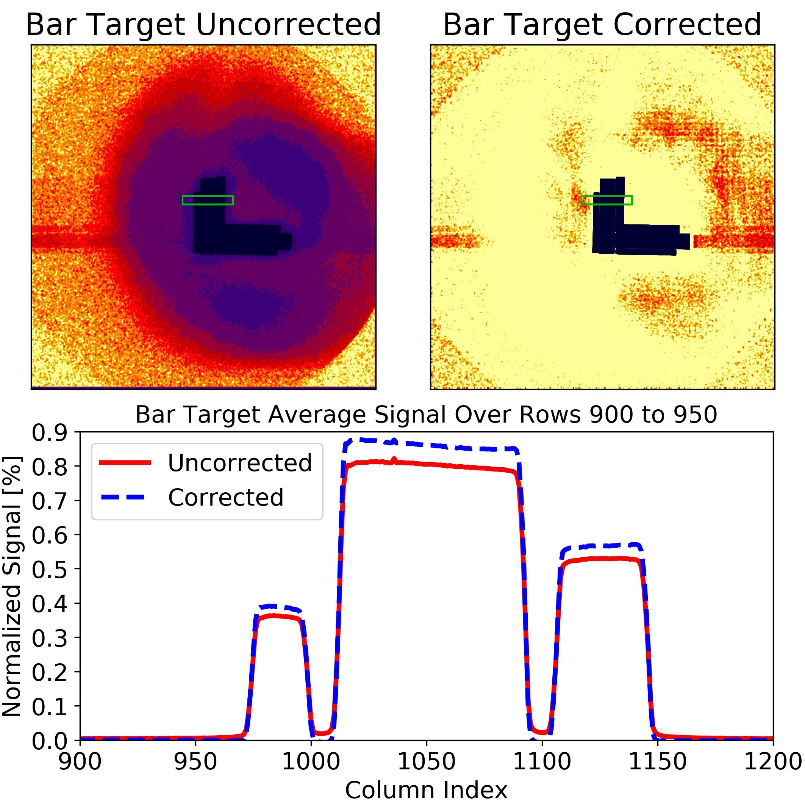
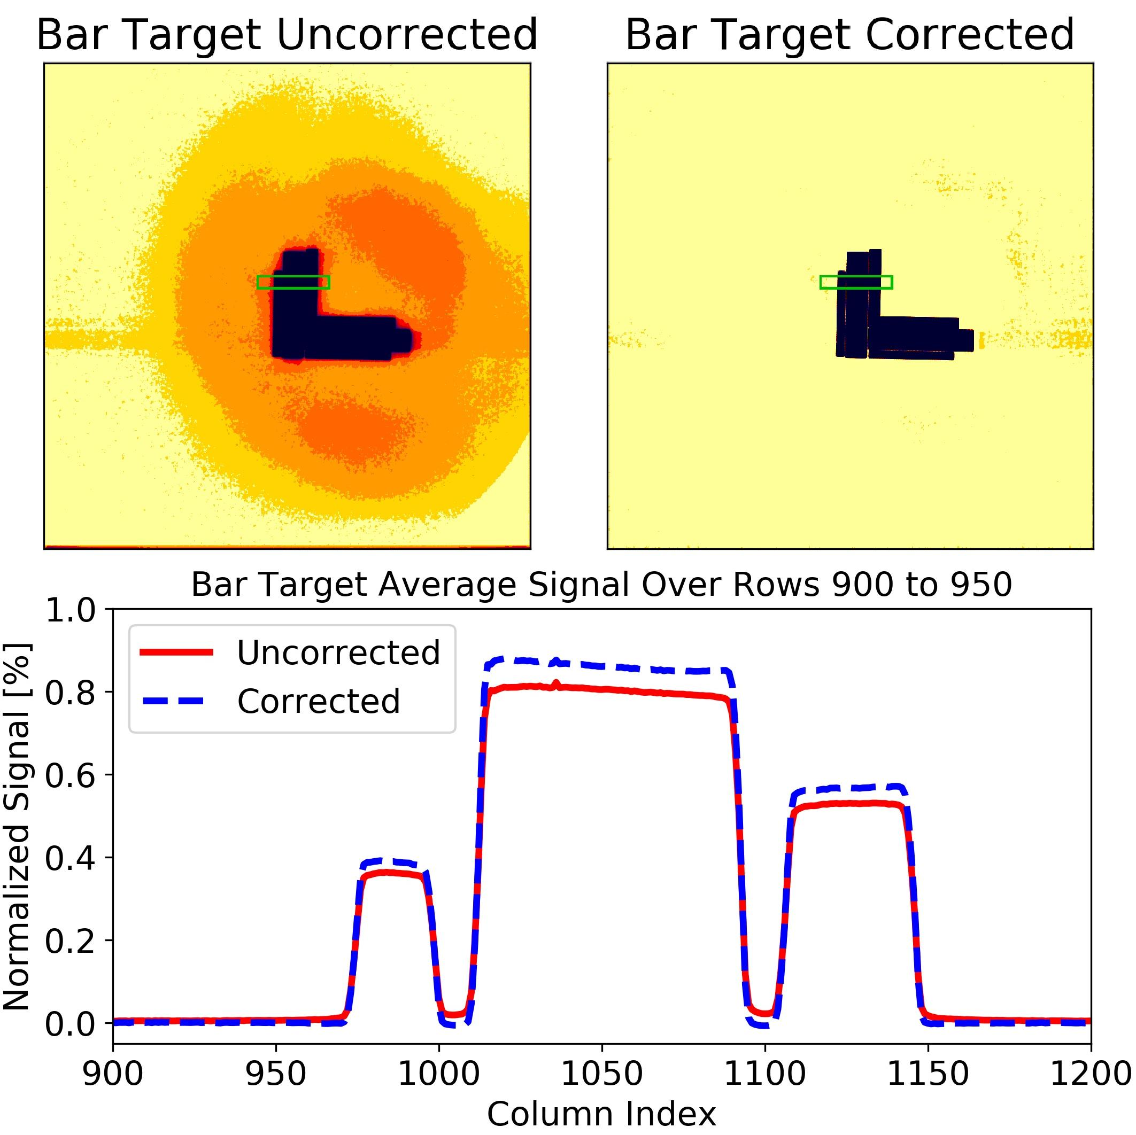
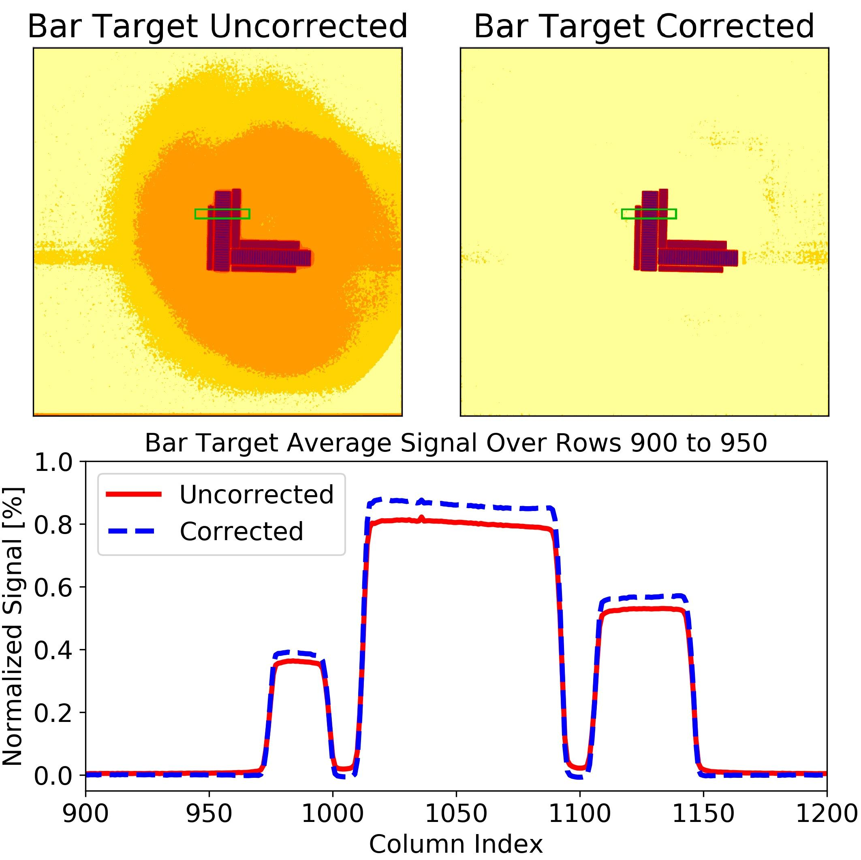
Figure 4.9.5: Bar target measurement for filter 8 from CalLM before stray light correction (left panel) and after stray light correction (middle panel). The color coding is as in figure 4.9.2. The right panel shows the average over rows 900 to 950 as a function of the column index, which is indicated by the green area in the full images. The stray light reduces the signal at the maxima and fills the gaps in between the maxima (red solid line). After the correction (dashed blue line) the signal at the maxima is “restored” and the signal in the gaps caused by the stray light is “cleared”.

Another example of how the PSF-model was improved is shown in figure 4.9.6, where a lunar image taken during CalMoon is presented. While we could not use the region on the moon itself to test the stray light correction, since we do not know the exact structure of the lunar surface, we could make use of the fact that outside the moon the signal must be basically zero and that the signal drops sharply to zero at the edge of the lunar disk since the moon has no atmosphere.

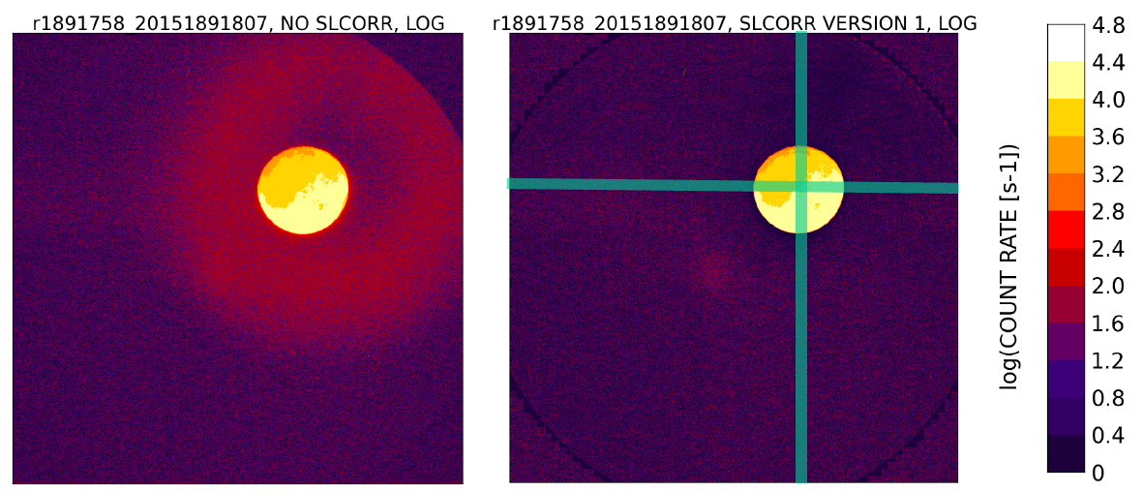

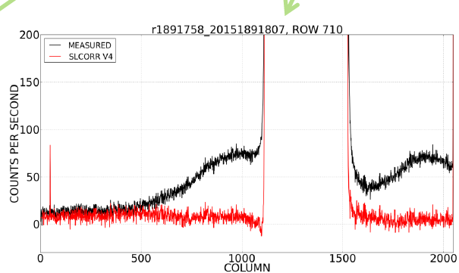
The figure caption is not clear. The description of the figure to the left
---------------- does not make sense.
Figure 4.9.6: Lunar image for filter 8 from CalMoon before stray light correction (left panel) and after stray light correction (middle panel) in logarithmic scale. The right panel shows the average over rows XXX to YYY as a function of the column index, which is indicated by the green line in the middle panel. Before the correction (red line) the signal outside the lunar surface is enhanced, mostly due to the ghost image, while after the correction (dashed blue line) it is approximately zero.

One check for the quality of the stray light correction that can be done for the operational data, is simply to look at the region outside the target (Earth or Moon), which should give a signal as close to zero as possible. We have analyzed the ratio R_{M} of the mean signal <M_{S}(t)> outside the Earth over the mean signal <M_{S1}> on the Earth for the first year of EPIC data in orbit R_{M} = <M_{S}(t)>/<M_{S1}>. For 8 of the filters, R_{M} ranged from 0.8% to 2.2% before stray light correction was applied, and from -0.1% to +0.2% after the correction, which suggests an excellent performance of the stray light correction algorithm. An exception is filter 9, where the R_{M} numbers are 2.8% and 0.7% respectively, while still an improvement by a of factor 4, but not of the same quality as for the other filters.

Another way to test the quality of the stray light correction is described in Geogdzhaev and Marshak [2018], where absolute calibration constants for EPIC filters 5, 6, 8 and 10 are found through comparison with data from the Moderate Resolution Imaging Spectroradiometers (MODIS) on board the Terra and Aqua satellites. The authors applied their technique separately for dark scenes and bright scenes. When EPIC L1a calibration, especially the stray light correction, was done correctly, the two methods should give approximately the same calibration constants, otherwise they will differ. Their analysis showed that the agreement between the calibration based on the dark and bright scenes respectively increased by a factor of 1.7 to 3.3 after EPIC stray light correction was applied.

Figure 4.9.7 shows the stray light error (SLE) for the same images as shown in figure 2.3, i.e. from 8 May 2019 around 11:00 UTC. Here we define the SLE as the percent difference between the data before and after the stray light correction. The median of the SLE-distribution for the pixels on the Earth’s disk (“pixels on Earth”) ranges from -2% for filters 1 to 5 down to -4% for filter 8. This is because stray light causes a fraction of the energy from the pixels on Earth to spread to the pixels outside the Earth’s disk (“pixels outside Earth”). For the pixels outside Earth, the SLE goes towards infinity, since the corrected data are close to zero. Bright scenes (clouds, ice or high surface albedo like over Africa for the higher filters) have a negative SLE, which ranges from -6% for filters 1 to 6 down to -10% for filter 8 (this is based on the 1-percentile of the SLE-distribution for pixels on Earth). Dark scenes (clear sky and low surface albedo) have a positive SLE, which can exceed the scale of figure 4.9.7 substantially with values above 50% and even up to 100% for filter 8 (this is based on the 99-percentile of the SLE-distribution for pixels on Earth).
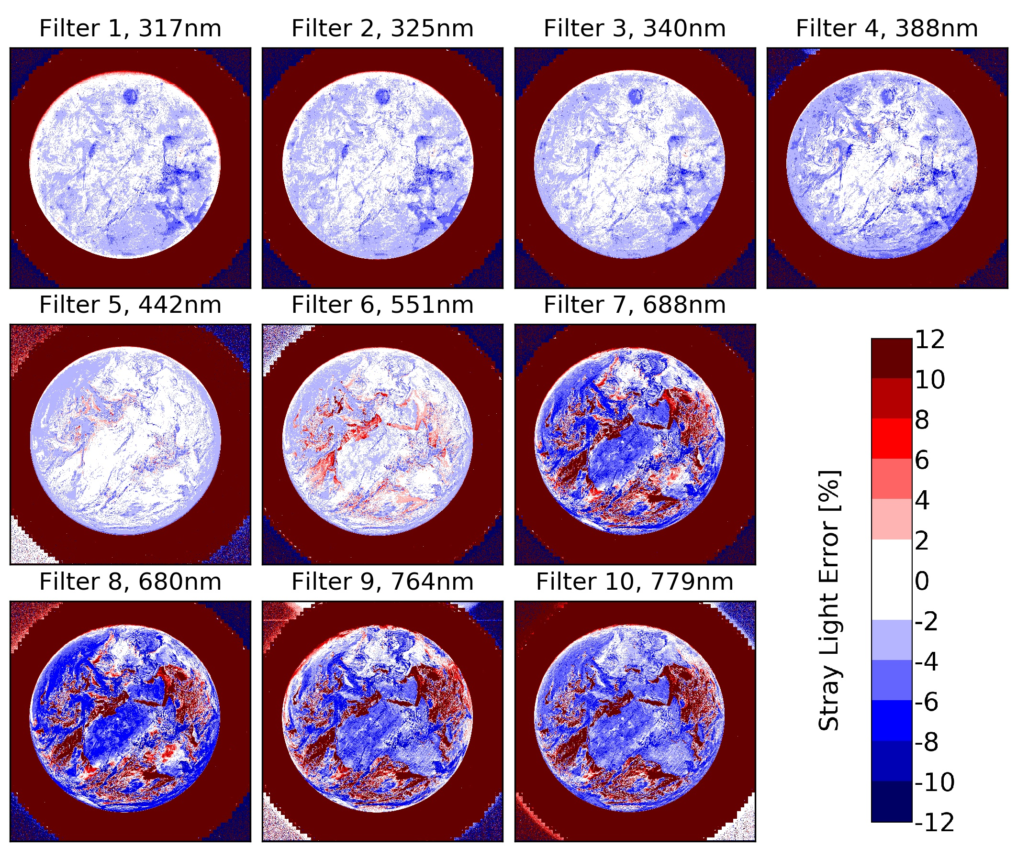
Figure 4.9.7: Stray light error for the EPIC images from figure 2.3 (8 May 2019 around 11:00 UTC).

5 Pixel size on ground
An important question for the data user is where does the light come from as measured by one EPIC pixel? This is often referred to as the “footprint” of a satellite pixel. The answer to this question is strongly related to the PSF, which describes how the light originating from a point source is distributed over the CCD. The core part of the EPIC PSF (figure 4.9.1) can be approximated by a 2-dimensional super Gaussian function with exponent 1.63±0.11 and FWHM of 1.34±0.11 pixels. The angular FOV of a pixel is given by the core PSF “mirrored on the center point” and convoluted over the extension of the pixel. It describes the angles where light originates that ends up in a given pixel. The FWHM of the EPIC FOV, which is obviously a 2D super Gaussian just like the PSF, is 1.73 arcsecs. The geographic footprint is the projection of the angular FOV on the Earth's surface, i.e. one needs to include the distances, angles, etc. from the telemetry. The blue lines in figure 5.1 show the footprint for the “standard case” of normal incidence on the ground (SZA = 0°) and the average Earth-Lagrange 1 distance. For this situation the footprint is approximately circular with a FWHM of 12.5 km, a 50% energy contour line with a diameter of 13.2 km (i.e., 50% of the energy measured in the pixel is from within this circle) and a 90% energy contour line with diameter of 24.9 km. The footprint increases with the distance of EPIC from the Earth, and also changes in size and shape for other places on the Earth with SZA > 0°.

As already mentioned in section 4.1, the images from all filters except the blue filter 5 are “binned”, i.e., the average over groups of 2 x 2 pixels are formed. The FOV for one of these binned pixels increases to 2.41 arcsecs, since the convolution is done over a larger area than in the unbinned case. This also changes the native footprint of the L1a data for these filters (red lines in figure 5.1). The “binned” footprint is not circular anymore, but has a FWHM of 17.5 km, a 50% energy contour line with a diameter of 16.4 km and a 90% energy contour line with diameter of 29.2 km. However, when the data of these filters are interpolated with the “help” of the unbinned filter 5 in the L1b processing, one can say that their resolution is improved, as if they had been measured in unbinned mode. Therefore, one can use the resolution numbers given in the previous paragraph and use the blue lines of figure 5.1 to approximate the footprint for the L1b data for all filters.

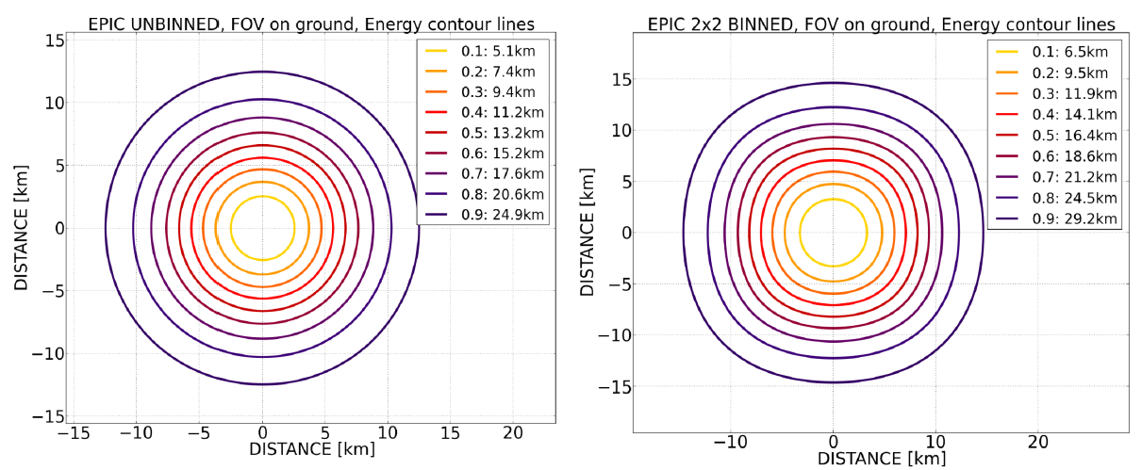
Figure 5.1: Contours of the EPIC footprint for a pixel for 0° satellite zenith angle at average Earth-Lagrange 1 distance. The blue lines represent the unbinned case, the red lines the case of 2x2 binned pixels. The light colors give the 50% level, i.e. 50% of the energy reaching the pixel comes from inside this region. The dark colors give the 90% level.

6 Uncertainty
A complete uncertainty analysis for EPIC L1a data has not been made. However, we can determine the read noise and the gain of EPIC, which allows us to estimate the signal to noise ratio (SNR) of an EPIC measurement:

(Equ3)

Where CC are the dark corrected counts ranging from 0 to about 4000. CC can be approximated by multiplying the L1a data (count rates) with the exposure times given in table 2.1. N_{READ} is the read noise, which is 3.9 counts for the operational EPIC readout mode. GAIN = 0.04 on average (it changes with the CCD temperature). The SNR is shown in figure 6.1. It ranges from 50:1 to 150:1 for dark scenes (lower values for higher wavelengths and higher values for short wavelengths that have significant Rayleigh scattering) and from 250:1 to 300:1 for bright scenes containing clouds or snow/ice.

For the binned images (all filters but filter 5), the SNR is the double the numbers shown in figure 6.1 and listed in the previous paragraph for L1a data.

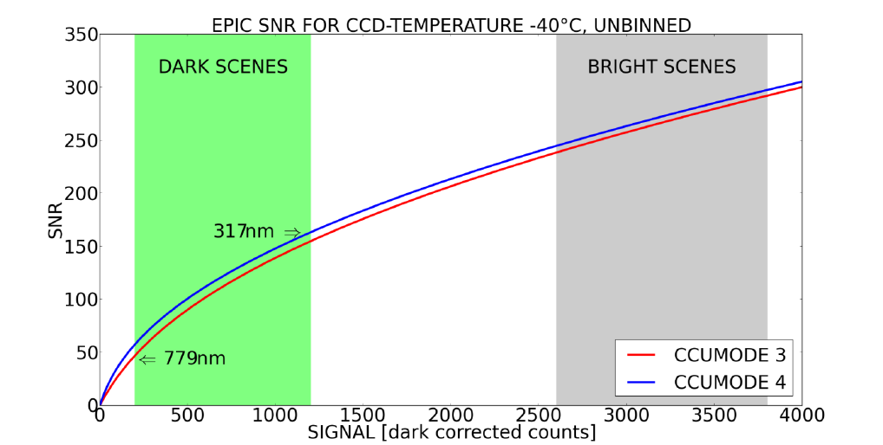
Figure 6.1: EPIC SNR for the operational readout mode at typical CCD temperatures. The SNR of dark scenes is smaller in the visible than in the UV due to the larger contrast between dark and bright scenes (see also figure 2.3).

7 Conclusion
We believe that within the available possibilities from pre-launch and on-orbit calibration activities, an adequate EPIC raw data calibration was obtained. The produced L1a data are corrected for all known instrumental effects and only need to be multiplied by a single number for each filter to obtain absolute calibrated radiance or albedo data. Before in-flight data were available, it was decided that no attempt would be made to determine the conversion from count rates to radiances for two reasons. First, the laboratory setup to produce an absolutely calibrated, homogenous, extended light source is a rather difficult task and would have exceeded the possibilities with respect to budget and schedule. Secondly, it is unlikely that the absolute calibration values obtained during pre-launch would have been applicable to the operation on orbit, as many factors, such as launch stress or the different environment and instrument illumination in space, usually modify the calibration significantly (see e.g. Kabir et al [2020]). Therefore the EPIC L1a data are given as corrected count rates and the 10 numbers needed to convert to radiances or albedo are determined by comparison to other satellites in a later processing step.

Several of the corrections described in section 4 follow well-established procedures for instrument calibration. However, for some of the steps we needed to develop rather novel techniques that have not been used so far to our knowledge.

- A latency correction method was determined. This was possible since the EPIC detector can be drained (read) from different CCD corners, the necessary measurements were made before launch (section 4.4).
- The flat-field corrections, which turned out to be the most critical part with respect to producing reliable L1a data, needed to be adjusted on orbit relative to their pre-launch values. This was done through comparison with other satellites and by applying a statistical analysis of all the EPIC images taken over a long period of time (section 4.8).
- A novel stray light correction method was developed based on partially binned PSFs to handle the huge dimensions of the matrices involved (section 4.9).

Since its launch in 2015, EPIC has been monitored for possible calibration changes, e.g. the dark count evolution (section 4.1), the number of hot pixels (section 4.2), or the radiometric stability from periodic lunar observations. The overall conclusion is that the observed instrumental changes are small, which we attribute to the benevolent conditions for the Lagrange 1 orbit. EPIC does not undergo periodic variations of extremely hot and cold temperatures like satellites in low Earth orbits (LEO), which move from sun to shadow every ~50 min. Furthermore, it is in a much more constant radiation environment compared to the instrument in LEOs, which cross the South Atlantic Anomaly at least once per day (see e.g. Li et al [2020]). Since it is always the same side of the DSCOVR satellite pointing to the Sun, the shielding from charged particles originating from the solar wind is much better. We believe that apart from the excellent Earth observing situation from Lagrange 1, the observations discussed in this document are another positive aspect of this orbit, which should be considered, when possible future missions are discussed.

8 Acknowledgements
This work was and is sponsored by NASA grants NNX15AB57G, NNX15AN07G, NNX17AC97G, 80NSSC18K0992 and 80NSSC19K0769.

9 References
- Atmospheric Data Science Center, 2016. Deep Space Climate Observatory, Earth Science Instrument Overview. Report available under https://asdc.larc.nasa.gov/documents/dscovr/DSCOVR_overview_2016-06-29.pdf [Accessed February 18 2021].
- Carn, S.A., N.A. Krotkov, B.L. Fisher, C. Li, and A.J. Prata, 2018. First observations of volcanic eruption clouds from the L1 Earth-Sun Lagrange point by DSCOVR/EPIC, Geophys. Res. Lett., doi: 10.1029/2018GL079808
- Cede A., J. Mobilia, H. Demroff, K. Sawyer, E. Hertzberg, and J. Herman, Stray light in EPIC, AGU Fall Meeting 2011, San Francisco, CA, USA, December 5-9, 2011.
- Cede A. and M. Kowalewski, EPIC optical design, calibration, and data correction, AGU Fall Meeting 2016, San Francisco, USA, 12 to 16 Dec, 2016.
- Christian K., J. Wang, C. Ge, D. Peterson, E. Hyer, J. Yorks, and M. McGill. 2019. Radiative forcing and stratospheric warming of pyrocumulonimbus smoke aerosols: first modeling results with multi‐sensor (EPIC, CALIPSO, CATS) views from space, Geoph. Res. Lett., doi: 10.1029/2019GL082360.
- Geogdzhaev, I.V. and A. Marshak, Calibration of the DSCOVR EPIC visible and NIR channels using MODIS Terra and Aqua data and EPIC lunar observations, Atmos. Meas. Tech., 11, 359–368, 2018.
- Herman, J., A. Cede, L. Huang, J. Ziemke, O. Torres, N. Krotkov, M. Kowalewski, K. Blank, 2020: Global Distribution and 14-Year Changes in Erythemal Irradiance, UV Atmospheric Transmission, and Total Column Ozone 2005–2018 Estimated from OMI and EPIC Observations, Atmos. Chem. Phys. doi: 10.5194/acp-20-8351-2020.
- Kabir S., L. Leigh, and D. Helder, Vicarious Methodologies to Assess and Improve the Quality of the Optical Remote Sensing Images: A Critical Review, Remote Sens., 12, 4029, 2020.
- Li, C., Krotkov, N.A., Leonard, P.J., Carn, S., Joiner, J., Spurr, R.J. and Vasilkov, A., Version 2 Ozone Monitoring Instrument SO 2 product (OMSO2 V2): new anthropogenic SO 2 vertical column density dataset. Atmospheric Measurement Techniques, 13(11), pp.6175-6191, 2020.
- Marshak, A. and Y. Knyazikhin, 2017: The spectral invariant approximation within canopy radiative transfer to support the use of the EPIC/DSCOVR oxygen B-band for monitoring vegetation. J. Quant. Spectrosc. Radiat. Trans., 191, 7-12, doi: 10.1016/j.jqsrt.2017.01.015
- Marshak, A., Herman, J., Szabo, A., Blank, K., Cede, A., Carn, S., Geogdzhayev, I., Huang, D., Huang, L. K., Knyazikhin, Y., Kowalewski, M., Krotkov, N., Lyapustin, A., McPeters, R., Torres, O., & Yang, Y. (2018). Earth Observations from DSCOVR/EPIC Instrument. Bulletin of the American Meteorological Society, 99(9), 1829–1850. doi: 10.1175/BAMS-D-17-0223.1
- Molina García, V., S. Sasi, D.S. Efremenko, A. Doicu, and D. Loyola, 2018. Radiative transfer models for retrieval of cloud parameters from EPIC/DSCOVR measurements. J. Quant. Spectrosc. Radiat. Transf., 123 228–240. doi: 10.1016/j.jqsrt.2018.03.014
- National Aeronautics and Space Administration, 2021. NASA Center for Climate Simulation: High Performance Computing for Science. https://www.nccs.nasa.gov [Accessed March 18 2021].
- National Oceanic and Atmospheric Administration, 2021. Joint Polar Satellite System: Ozone Mapping and Profiler Suite. https://www.jpss.noaa.gov/omps.html [Accessed March 5 2021].
- Sasi, S., V. Natraj, V. Molina-Garcia, D.S. Efremenko, D. Loyola, and A. Doicu, 2020: Model Selection in Atmospheric Remote Sensing with an Application to Aerosol Retrieval from DSCOVR/EPIC, Part 1: Theory, Remote Sensing, 12, 22, doi: 10.3390/rs12223724
- Várnai, T. and Marshak, 2009. A., MODIS observations of enhanced clear sky reflectance near clouds. Geophysical Research Letters, 36(6).
- Wen G., A. Marshak, W. Song, Y. Knyazikhin, M. Mõttus, and D. Wu, 2019. A relationship between blue and near-IR global spectral reflectance and the response of global average reflectance to change in cloud cover observed from EPIC on DSCOVR. Earth and Space Science, 6. doi: 10.1029/2019EA000664.
- Xu, X., J. Wang, Y. Wang, J. Zeng, O. Torres, J. Reid, S. Miller, J.V. Martins, and L. Remer (2019), Detecting layer height of smoke aerosols over vegetated land and water surfaces via oxygen absorption bands: hourly results from EPIC/DSCOVR in deep space, Atmos. Meas. Tech., 12, 3269–3288, 2019, doi: 10.5194/amt-12-3269-2019
- Zong, Y., S.W. Brown, B.C. Johnson, K.R. Lykke, Y. Ohno, Simple spectral stray light correction method for array spectroradiometers, Appl. Opt., 45 (6), 1111-1119, 2006.

